THE ART-PRACTICE CLASSROOM: A FRAMEWORK FOR TEACHING AS ART

By
Emily Elisabeth Elliott

THESIS

Submitted in partial satisfaction of the requirements for the degree of

MASTER OF FINE ARTS

in

SOCIALLY ENGAGED STUDIO ART

within

GRADUATE STUDIES

of

MOORE COLLEGE OF ART & DESIGN

Graduation 2021
©Emily Elisabeth Elliott

Accepted:

___________________________________________
Daniel Tucker, Graduate Program Director

Acknowledgements
This paper is the product of all the experiences of 43 years of learning. It is my belief that each interaction that I have had, each experience and each environment in my life were teachers leading me to this moment. As such it would be impossible, even if my memory could produce it, to list all the teachers I have had. I am grateful for every moment, regardless of how it felt at the time, for coalescing into the sum of experiences that brought about this thesis.
But as with any lifetime there are the standouts. The events, people and places who remain with us in thought and action regardless of their physical presence. I will attempt to recognize some of them here.
The greatest of these is my mother, Lynn Elliott, who taught me how to live. Beyond teaching me to talk, walk and read she taught me how to continue. How to work, how to persist and how to grow. She has supported me in my decisions, whether she agreed with them or not and she didn’t say ‘I told you so’ (too often) when she was right. Because of my mother, I am here, right now, despite circumstances that might have determined otherwise.
My big brother Todd Elliott taught me how to think for myself and gave me things to read and listen to that were real and deep. I will continue to consult the Todd-opedia with my existential questions and to discuss bad taxidermy.
I could not have completed this program without the help, love and support of my daughter Fiona Watts, my boyfriend Alex Clothier and my dear friend (and “wife”) Carole Ellerkamp. With humor, baked goods and loving reminders they made this journey possible.
My family, by blood and by choice, are entirely responsible for making me this way. Thank you.
My teachers, students and friends (who are frequently one and the same) from the Crefeld School who let me be me, even when I was a spazz, as a student or as a teacher (Aaron especially). Crefeld is my home place, and you are all my family.
My teachers and colleagues, from all my schools, have continually awed and inspired me with your passion, your love and your brilliance. My professors at Moore made me look at my work from a new perspective. My cohort, Ann, Ashley and Qiaira … I’m pretty sure there is a meme for this.
Lisa Kasser and everyone at Burn Brae Day Camp who make it possible to truly practice my art.
My mental health professionals made sure I survived my past in order to experience my present. Special thanks to Rebecca who gave me my 2021 mantra “the best thesis is a finished thesis.”
To my kids, especially the ones who were hard on me, I’m sorry I wasn’t better for you, but you made me better.
Thanks to all of you for listening to my ranting and raving about education, schools and the state of the universe. I hope that I can contribute in some small way to making it better.

THE ART-PRACTICE CLASSROOM: A FRAMEWORK FOR TEACHING AS ART
By
Emily Elisabeth Elliott

Submitted in partial satisfaction of the requirements for the degree of
Master of Fine Arts in Socially Engaged Studio Art

ABSTRACT

From its inception in 1867 the Department of Education has been trying to establish, and define, effective education in the United States. The role of public education in America has changed over time to become more inclusive, if not more equitable. In each iteration of federal education law, the overarching goal was to codify, standardize, and measure student learning. The focus in most public schools throughout the country has been on test scores and accountability. In the search for a standard, common goal for American education, the individual needs of children have been lost.
In the 1960s there was a significant shift in thinking about education and learning away from standardized models and toward more individualized and experiential learning. This was also occurring in the art world and academic art community. Artists were creating schools as works of art and casting aside traditional academic structures in art schools as well as embracing post-conceptual notions of art as experience inspired by John Dewey’s early 20th century writings. These schools-as-art, teaching-as-art, and experience-as-art works formed the foundations for what we now refer to as social practice art or dialogic art.
There are several contemporary social practice artists who engage in certain types of pedagogic art like creating schools, open lecture formats, or training participants to create a certain type of social experience. In each of these circumstances the artists retain control and authorship over the work and the products thereof.
Through literature review and case studies this thesis defines and develops a framework for teaching as an art practice. In the proposed classroom framework, the artist-teacher releases creative control and authorship of any products to the participant and acts as a facilitator of the work of the student. The work and product of the artist -teacher is the co-creation of a classroom where student needs are centered.
The framework proposed in this paper the Art-Practice classroom consists of elements of emancipatory pedagogy, social practice art and process-based learning to re-focus educational practice back on the individual needs of students. The framework consists of 4 guiding principles; learner centered, project based, focused on learning to learn and community connected.

Table of Contents
Acknowledgements 1
ABSTRACT 2
Introduction 5
Definitions of Key terms 7
How Did I Get Here? 9
The Framework 16
Teaching as Art Practice 20
Practice, SEA and Transpedagogy 20
Teacher-artists in action 25
Ben Volta 25
Pepòn Osorio 29
The Framework: How it works 35
Section 1: Learner centered 36
Section 2: Project based 38
Section 3: Learning to learn 40
Section 4: Community Connected 42
Conclusion 45
Bibliography 50
Illustrations 54
Artifacts/appendices 57
I. The Framework 57
II. My pledge 74
III. Case studies 75
IV. Art works 87
A. Pieces 87
B. Collaborative Art Project 89
C. Building Spaces 94
D. Recomposed 2021 98

THE ART-PRACTICE CLASSROOM: A FRAMEWORK FOR TEACHING AS ART

Introduction
“The creation of an environment in which (this) exploration is enabled is the role of the teacher. They operate as curators of performative educational experiences, at once instigator and participant. Lessons are performative participatory art.”- Henry Ward

As an artist, I like to explore any media option that I can get my hands on. I am process focused. I like to play with materials and find out what they can do. I love to learn about new materials and techniques and apply them to my creative practice. When I find a new material or technique I listen, ask questions, research, and learn through experimenting. When I am at my best as a teacher, I am focused on the process of learning, discovery, and play. I am at my best when my students and I combine forces and design experiments in making. I am at my best when I am listening, questioning, researching, and experimenting along with my students. My best teaching practice parallels my creative practice.
Some of my finest teaching moments were experiences, not lessons. One summer, at Burn Brae Day Camp of Creative and Performing Arts, my theme was ‘how it’s made.’ We made felt paintings starting with raw wool, paper out of whatever fibrous material we could find and paint from plants, rocks, and dirt. The art we made was definitely not portfolio worthy, but the experience is one that my students from that summer still talk about. My creative practice that summer was to facilitate learning experiences for my students. I was practicing the art of teaching.
I have had time, through Moore’s Socially Engaged Studio Art MFA program, to reflect on my teaching and to process the experiences I have had and those I have created for my students. A teacher can bring joy and love to learning or cause anger, distrust, and pain. I wish I could say that I only brought the former into all my classrooms, however, I know that I have caused harm. I was not always the best teacher. I love(d) my students. But that love wasn’t enough to counteract my role in educational systems of oppression. I am determined to do better. I am determined to practice the art of teaching.
This determination led me to the following questions:
How can my teaching be a socially-engaged art practice?
How can that practice manifest in public K-12 classrooms?

In this paper I will describe one approach to the art of teaching. This is the method that I will follow in my future teaching experiences. The method I suggest approaches teaching as a relational, socially engaged art practice. My research includes educational philosophy, socially engaged art pedagogy and case studies of current socially engaged artists. This paper is composed of the research that prompted me to make a pledge to my future students and a framework for an art practice classroom. I came to this research through my experiences as an artist, a student, and an educator.
I will begin with a definition of key terms to clarify the meanings in this context as some terms have multiple associations. Following the key terms is a section on my background and experiences in teaching and learning which lead to the development of my framework, followed by a brief description of the framework. The third section addresses the positioning of teaching as a socially engaged relational art practice. The final section details the framework Art-practice classroom and the role of the Artist-teacher.

Definitions of Key terms
  - Art-practice classroom- A student centered classroom which is focused on the process of learning with the goal of continued learning.
  - Artist-teacher- One who engages in the art of teaching and creating an Art-practice classroom.
  - Socially Engaged Art (SEA)- art that is collaborative, often participatory and involves people as the medium or material of the work
  - Practice- Refers to the ways in which an artist goes about his/her work. Artistic practice goes beyond the physical activities of making artistic products and can include influences, ideas, materials as well as tools and skills.
  - Relational Art- A term created by curator Nicholas Bourriaud in the 1990s to describe the tendency to make art based on, or inspired by human relations and their social context.
  - Dialogical Art- Refers to an art practice in which the interaction and dialogue between participants is the artwork.
  - Transpedagogy- A term created by Pablo Helguera to describe works by artists which are also works of pedagogy
  - Critical Pedagogy- A teaching approach which attempts to help students question and challenge domination, and the beliefs and practices that dominate

How Did I Get Here?
“Education either functions as an instrument to…bring about conformity or it becomes the practice of freedom, the means by which men and women deal critically and creatively with reality and discover how to participate in the transformation of their world.” -Richard Shaull
My teaching and learning experiences have had a profound effect on my life, my goals, and my values. The experiences that follow are given as both background and explanation of how what I will refer to as the Art-practice classroom and the Artist-teacher came into being in my mind.
During my educational journey, I have had great teachers who have treated their students as valuable individuals and really awful teachers who treated their students with disdain. I have been to wonderful schools and terrible ones. I have been an excellent teacher and an awful one. I have been taking notes. I have been keeping track of my educational failures and successes, those of my colleagues and of the schools/school systems themselves. I do this, not to simply catalog, but to look for solutions to the large number of problems in our educational system. Through research and experience I have found, and so have a myriad of others, that there is no one-size-fits-all approach to teaching and learning. These educational processes need to be as unique as the people pursuing them. That is not to say that there is no wrong way to educate; there are plenty of those, including trying to fit one set of learning goals and guidelines to all people, which is what we do in America today. This factory style of education was initiated in the early 1900s, during the height of industrialization in the US. It was designed to educate factory workers, secretaries, and low-level management (the company owners and their children went to private schools).
Over the last 21 years I have been teaching in a professional capacity - teaching multiple disciplines and ages ranging from infant to adult. I have taught in public schools, private schools, camps, daycares, and private homes. Throughout my career and my life, I have sought to be a better teacher than I was the day before. I consider teaching my vocation and my art.
I don’t remember a point in my life where I didn’t want to be a teacher. I have been a teacher in various capacities since the age of 15. I have taught art, dance, rock climbing, health, Phys. Ed., and social studies, among others. To me, the joy of teaching is sharing the learning experience, showing someone how to do something new and learning from them new ways of seeing things. The discipline I was teaching never mattered much, I am a teacher first, and a specialist second. The creativity and flexibility required to create a learning environment which incorporates various access points for multiple students is a challenge I embrace. For me working with individual students and seeing them work through a problem or challenge and come to a solution is the most inspirational experience.
After graduating with a BS in art education, my first 8 years of teaching were in the school I attended for high school: The Crefeld School. Crefeld is a small private progressive school in Philadelphia, designed for students who thrive in smaller settings. The Crefeld School was founded on ideas of progressive education and is guided by the “10 common principles” of Coalition of Essential schools. Some students at Crefeld have learning differences, some are gifted, some just ‘march to the beat of a different drummer.’ The Crefeld community is made up of people from diverse backgrounds, with diverse needs. At Crefeld there is no one way of doing things, teachers must be flexible, creative, and open to change. I got to experience the way my teachers, now my colleagues, were constantly evaluating their practices and learning new methodologies to improve on their skills. I was a part of a community of learners who were in a constant state of growth and change. The 8 years I taught at Crefeld and the 4 years I attended, provided me a firm foundation for self-evaluative practice, collaborative teaching, differentiation, community connectedness and social responsibility. These practices have become a founding influence in the creation of my Art-practice teaching framework.
For a few years I worked as a substitute in longer term positions and other jobs while hunting for an art teacher position. In 2013, I accepted a position with the School District of Philadelphia (SDP) as an art teacher at Penrose school in the Southwest of the city. The experience was baptism by fire. There was no introduction just ‘Here’s your classroom, your schedule and a handful of supplies. Good luck.’ I learned a lot, but most of what I learned was how little of the education system in Philadelphia was about students. My years in SDP exposed me to a new set of teaching practices, both effective and ineffective, and a new set of colleagues and students to learn from.
Over the next 6 years in SDP, I adapted. I had to adhere to ‘best practices’ and displayed ‘look fors’ like posting objectives for each class, anchor charts and word-walls, among the many artificial artifacts of the contemporary classroom. The more I tried to inhabit that reality the more I became a part of a system which did not put the needs of the students first, what educator Bettina Love calls “the educational survival complex”. I experienced some of the worst that public education has to offer, and it didn’t have to be that way. I worked with great teachers and wonderful kids and we were all being hamstrung by the requirements of a system designed to punish. As a certified K-12 art teacher, I found that the delivery methods I was using in my classroom were not in line with my pedagogical beliefs. I believe in problem solving, personalized education. What I was doing in my classroom was a model that educator and activist Paulo Freire refers to as the “banking method,” where students are empty vessels in which information is “deposited.” This model of education is historically the dominant form in most traditional schools and according to Freire is one the tools of continued oppression by the dominant culture. My complicity in this domination and oppression goes against my core beliefs and my teaching philosophy. I was raised by educators who were both creative in their methods in the classroom and supportive of inquiry at home. I was disillusioned, frustrated, angry, ashamed, anxious, and depressed. In 2019, I could no longer stand to be a part of the problem and like many other teachers, I quit.
Fall of 2019 found me in my current program: MFA in Socially Engaged Studio Art at Moore College of Art and Design. When I first arrived, I was focused on making art about the inequities in public education that I had witnessed while working in SDP. I made art with data about school funding and poverty. I made “political” cartoons about school injustice. While creating these works it was pointed out to me that I was not engaging in the truth about what drives me. I dug down and asked myself “What am I really good at? What is it that I really want to do?” Teach. I teach. I create the classroom environment where learning can take place. That is my art. That is my practice.
The truth is that I get fired up about teaching. I love teaching; however, I hate that my students don’t have the same opportunities that I had, and my daughter has simply because of where they live and the continued systemic oppression of Black and Brown people. It is clear to me that there is something incredibly wrong with the education system. The inequities in public education run the gamut from insufficient funding, to over large class sizes, to lack of community engagement. I can’t solve these larger problems. I choose to focus on what I can do in my small way to support my students’ success.
Through my work in Moore’s Continuing Education Office, I had been researching educational practices and the future of the education system. I read The New Education by educator and scholar Cathy Davidson and found that the methods and principles we have used at Crefeld since the 1980s, were just starting to be recognized as the methods needed for the contemporary world. Principles like trust and decency, project-based learning, depth over breadth, commitment to community and teacher as coach. Davidson calls for project-based learning, multi-disciplinary content, learning to learn, student-centered learning and community-minded education. The author and educator Ken Bain echoes these ideas in What the Best College Teachers Do. Bain emphasizes student engagement and regular reflection and feedback processes for student, teacher, and programs. In text more specifically about art and art education I found further discussion of multidisciplinary creations and life-long learning in the context art education.
When the shut-down began in March of 2020 due to the Covid-19 pandemic, my pedagogical ideals were put to the test. Students and teachers all around the world had to make a sudden and drastic shift from in-person learning to an entirely online format and so did I. How does an artist/teacher that relies on collaboration, work with others when we can’t be with our students/collaborators? What can we do when we have lost access to spaces and materials? We learned together. Through conversations with other artists, students, and teachers, mainly through Zoom, I learned a whole new set of tools and skills that help to facilitate collaborative creation. I connected to new people via Facebook and Instagram to create a crowdsourced artwork. I also called for participants for a collaborative art making experience for students through the same social media outlets. That group was to be the starting point for a student driven project framework for the Art-practice classroom: a set of guidelines derived from Socially Engaged Art, dialogic practices, and democratic pedagogy. This framework is the foundation for my life-long learning process in working with others to help them to learn and grow. I don’t have the answers to the problems of our world, but I firmly believe that our solutions are the students sitting in my classroom every day.

The Framework
“We want our students to move into the world as critically engaged citizens. We believe such citizens ask questions such as “So what?” We believe they do so in their pursuit of the facts, in their attempt to put things in perspective, in their seeking of creative solutions, and in their commitment to the common good.” – George Zeleznik

The framework for the Art-practice classroom is a conglomeration of existing educational philosophies, pedagogy and methods combined with aspects of Socially Engaged Art practices and community engagement. The framework consists of 4 guiding principles. An Art-practice classroom is one that is learner centered, project based, focused on learning to learn and community connected. Rooted in principles of critical pedagogy, democratic teaching, and progressive education, and informed by the work of Socially Engaged Artists and creative placemaking, this outline will serve to guide my teaching as I enter a new phase of my practice. Paulo Freire, Brazilian educator and theoretician, looks at education and the role of educators as a means of liberation when done properly. The method he suggests for liberatory education is what he refers to as “problem-posing education.” In a system of problem-posing education the student is engaged in the process of thinking about problems directly related to themselves in full context. In other words, students are presented with a problem and all the attendant complications and connections.
Educator and philosopher John Dewey knew in 1916 that deep learning resides in process and experimentation. While some educators are still trying to understand this concept, science and artists have known the truth all along: we learn best and most from active experimentation and collaboration as opposed to rote. Socially engaged artists looking to engage with communities are also aware of the benefits of critical engagement and democratic methods in collaborative work. Freire, writes about critical engagement of students through “problem-posing education” in which the teacher and students alike are engaged in solution finding and learning from one another. Author and educator bell hooks wrote in Teaching to Transgress:
“When education is the practice of freedom, students are not the only ones who are asked to share, to confess. Engaged pedagogy does not seek simply to empower students. Any classroom that employs a holistic model of learning will also be a place where teachers grow and are empowered by the process.”
The same type of engagement can be found in creative collaborative spaces. In democratic socially engaged art practices the artist is engaging with stakeholders as a learner among learners. The artist should be learning about their co-artists and the community they are joining as they work on a process of mutual benefit. This touches on art historian/author Grant Kester’s idea of dialogical practice:
“the artist is not always the one ‘presumed to know,’ and the viewer qua participant is able to produce his or her own transformative knowledge. The subject positions, author and recipient of authored material, for example, and modes of agency, fluctuate through the course of a given project.”
Kester’s idea of dialogical practice also aligns with Freire-ian educational practices in which the teacher is student and student is teacher.
In the Art-practice classroom the role of the teacher is that of facilitator and collaborator with the students. The teacher is also a learner, and the learner is also a teacher. Each individual is met at their own starting point and is considered an expert in their own experience. In an Art-practice classroom, projects and goals are made according to individual need and desire and the curriculum is designed to meet them. Relationships and trust are built and worked on as a natural necessity for collaborative work. The teacher works to facilitate the work of the student, makes connections outside of the classroom and seeks resources to support student development. The Art-practice classroom exists for long-haul learning. One lesson may last a month or a year or continue into the next year. In an ideal environment, the teacher in an Art-practice classroom would be supported by an administration whose role is also facilitator of student and faculty development.

For complete outline see appendix I
Framework for the Art-Practice Classroom

Teaching as Art Practice
The intelligent mechanic engaged in his job, interested in doing well and finding satisfaction in his handiwork, caring for his materials and tools with genuine affection, is artistically engaged. - John Dewey

Practice, SEA and Transpedagogy
To address the topic of teaching as an art practice we must look at the issue from several theoretical perspectives. First, it is valuable to look at how different thinkers view “practice.” Practice, described by activist and artist Caroline Woolard, is “a way of doing things intentionally on a regular basis to develop an ability or awareness.” It seems obvious to me that teachers are intentional and regular in their application of their trade and if they are good teachers then they are developing their ability. John Dewey believed that “﻿even a crude experience, if authentically an experience, is more fit to give a clue to the intrinsic nature of esthetic experience than is an object already set apart from any other mode of experience.” In Dewey’s mode of thinking, if the mind is engaged and focused then the experience is an aesthetic experience, or an art experience. It then follows that one involved in creating an experience for others is engaged in creating art.
But what about the art? Where is the artwork? What is the teacher making? A look at the idea of relational aesthetics and dialogic practice helps to position teaching in the sphere of art making. Relational aesthetics, as defined by curator Nicolas Bourriaud is “a set of artistic practices which take as their theoretical and practical point of departure the whole of human relations and their social context, rather than an independent and private space.” In other words, the art is what happens in the relation of humans, one to another. In the classroom the traditional teacher is making lesson plans, worksheets, curriculum, and other class materials, but one would hardly consider that art (or would you?). The Artist-teacher, (of which a vast number of teachers are whether they know it or not) is making the space and the conditions in which student development can take place. According to Ken Bain, author of What the Best College Teachers Do, the teacher needs to “create a natural critical learning environment”. The creative product in the Art-practice classroom is of the physical, intellectual, emotional, and communal place where deep learning can occur for each individual student regardless of the starting point. The relationship and community building in the classroom seems to fall into Bourriaud’s relational aesthetic quite nicely.
An Artist-teacher is also engaging in the necessary discussions and dialogues for educational outcomes. I would argue that these communications between classroom community members in the Art-practice classroom are dialogical art. Grant Kester describes this as art in which “discourse is not simply a tool to be used to communicate an a priori ‘content’ with other already formed subjects but is itself intended to model subjectivity.” To me this also seems to be a socially engaged art practice. Socially engaged art practice is, according to curator Nato Thompson, “participation, sociality and the organization of bodies within a space” which perfectly describes any classroom. As Artist-teacher Henry Ward puts it “The creation of an environment in which (this) exploration is enabled is the role of the teacher. They operate as curators of performative educational experiences, at once instigator and participant. Lessons are performative participatory art.”
The connection of teaching to art practice has been made by others for decades. Joseph Beuys called teaching his “most important work”. In the 1960s and 70s Beuys was engaged in creating free universities and open art classes in Germany. Beuys approached teaching as an art through the performance of the lecturing teacher and displayed the artifacts created in his lectures as the evidence of the art. Beuys practices, according to Claire Bishop “form the most central precursor of contemporary socially engaged art, intersecting artistic goals with social, political and pedagogic ambitions.”
Other artists whose work lies at the intersection of art and education include Tania Bruguera and Ernesto Pujol. Bruguera and Pujol are both considered SEA artists and have written extensively on their practices. According to Bruguera she is “interested in creating an environment that allows transforming ‘the audience’ into ‘a citizen.’ Bruguera places participation as not the goal of her work but as work itself. She takes the position that social interaction and behavior are the art instead of the product of the art. Bruguera refers to her work as “Arte De Conducta” or behavior art. In her work Cátedra Arte de Conducta, she created the conditions for the creation of political art in which “aim is to produce a space of free speech in opposition to dominant authority (not unlike Freire’s aims in Brazil) and to train students not just to make art but to experience and formulate a civil society.”
Ernesto Pujol is a social choreographer, a multidisciplinary performance artist and teacher. Pujol says this about his practice: “As a contemporary artist [I see] no difference between my studio and my teaching practice (they form a seamless legacy), I write from the ground up, from a hands-on perspective as an artist instructor seeking to regenerate the studio as classroom.” In his work “The Listeners” people who had been trained to listen, sat silently in a room and listened to members of the public who came to the exhibition. Pujol selected a room that was slightly secluded and quiet that needed to be sought to be found. He trained participants to listen without judgement, and they listened to people who came for however long they needed to. The piece is used as a “laboratory of an ephemeral listening school” or a model for what is critically necessary skill in the modern world. Pujol as an artist sets up spaces to create experiences for people to have and critically reflect on. The key factors of Pujol’s making in this context are his selection of space, the selection of listeners and the training (teaching) of those listeners. In performative art like The Listeners, the role of the artist is to set the conditions of the work, but the product and effect are up to the individual participants.
Beuys, Bruguera and Pujol are all engaged in what author and artist Pablo Helguera calls transpedagogy, “the migration of the discipline and methods of education into art-making, resulting in a distinct medium where the artwork is constituted simultaneously of a learning experience or process and a conceptual gesture open to interpretation.” In his book Education for Socially Engaged Art Helguera describes what is unique in transpedagogical art works; “﻿the practice of [art] education is no longer restricted to its traditional activities, namely art instruction (for artists), connoisseurship (for art historians and curators), and interpretation (for the general public)”. So, through transpedagogy, art education is not being coded for/by the art insider, instead, the creativity of the art is the experience of all participants in these works.
The preceding artists are examples of practices which include pedagogy. They indicate that teaching-as-art has a historical reference and contemporary practitioners. While some of these practices can be translated to K-12 classrooms I needed to look more specifically at artists who work directly with K-12 students in public schools. That research involved delving deeper into the realm of individual teaching artists’ practices. Specifically practices which involve students in Philadelphia public schools. The following are case studies of two Philadelphia teaching artists and their projects which were created with students from Philadelphia schools.

Teacher-artists in action
“By embracing art as pedagogy, artists can promote the creation of communities with
interests that are outside of commerce and traditional artworld hierarchies, thus at the same time making a kind of art that can contain personal meaning and circumventing the problem of the artwork as an object of plain consumption. In these works, what is consumed if anything is presumably a type of knowledge.” -Pablo Helguera

Ben Volta
Ben Volta is a teaching artist and muralist based in Philadelphia. Volta’s teaching practice also uses aspects of the Art-practice classroom framework. His work with students is project based, multidisciplinary, community connected, and uses research methods. Volta adapted his teaching techniques from his experience working with Tim Rollins and the Kids of Survival (KOS) in the early 2000s. According to Volta, the process with KOS was conversational and organic. The group worked from a text, talked about it and found where they connected to it and then began making art in response to those connections.
The project We Are All Neurons was a collaborative project initiated by Mural Arts and artist Ben Volta in 2013. What started as an off-the-cuff remark to Jane Golden, founder and executive director Of Mural Arts Philadelphia, became a moving mural in the form of a wrapped SEPTA subway car on the Market -Frankford line. In partnership with SEPTA, Mural Art’s LEAPs Program and Waring Elementary, 27 students, 4 assistants and artist Ben Volta, worked for two and a half months after school to create the design for the wrapped subway car. Inspired by President Obama’s BRAIN Initiative, the artists explored the connections inside the brain and the connections made through the subway line. The final work that wraps the train is a series of neurons drawn by the students, colorized, and overlapping. The interior of the train has an explanation and images of the creative process.
The Market-Frankfort line runs from the heart of North-East Philadelphia through Center City and out to West Philadelphia’s 69th Street transportation hub. Thousands of folks ride this line to get to work, school or entertainment venues every day. Trains on this line run from 4:40 AM to midnight on weekdays and 24 hours on weekends. This transit line is essential in the city, allowing folks from distant parts of the city to access the city center and beyond. While the choice of the line was up to SEPTA, Volta began his design work by discussing the role this transit route plays in the city.
For the mural Micro to Macro, Ben Volta partnered with Morton McMichael Public School in the Mantua section of Philadelphia to create a 12,000 square foot mural which covers 3 faces of the school building. With funding from PECO, Philadelphia Department of Human Services and the Lindy Family, Mural Arts was able to pilot what would become their Arts Integration program.
Over the course of 14 months Volta worked with students at McMichael. He started out sitting “as a student” in the 7th grade science and math classes at McMichael to find out what the students and teachers needs were and then help find creative connections. From the beginning of the project, Volta knew that the product would be a mural on the school building, and that his role was to facilitate the process of creating the content of the mural. The mural was requested by the school administration to cover the facade and make it more welcoming. During the 14 months at McMichael the process involved an average of 50 students per week, both during math and science class and in the self-selected after school program at McMichael School. The mural begins with a magnified view of atoms, molecules, and DNA through synaptic connections at the entrance and moves to a life-sized view of trees then zooms out to show the Earth from space, the galaxy, and the sun. The image lightens the school building and creates a more welcoming environment, but according to Volta the impact is in the experience of the students who participated.
Engaging students in activities that require critical thinking and connection building between themselves and the world around them should be a main goal of education. Volta’s process is similar to Rollins’ but instead of text, he began with the context in which he was working; the train in the case of We are all Neurons and science and math classes in the case of Micro to Macro. In each case he presented the students with a problem to be solved, wrapping a train with a moving mural and creating a mural on the school. The process of working with students in a critically engaging manner encourages students to think critically in other aspects of their lives and become more creative thinkers in the long term.
According to Volta, each conversation “started with only the goal of making something together.” The artist brought no ideas himself but added to the conversation as they went along. By allowing the conversation to flow naturally and adding connections Volta was encouraged students to claim ownership and authorship of the work. Each group began the process by brainstorming what they did know, instead of trying to discover what they didn’t know. People know a lot more than they realize, especially children. Connecting what individuals do know with a new process reinforces learning and engages metacognition (learning how to learn).
For We are all Neurons, the process began with sketching tracks and connecting them while talking about what a train does. Following the thread of the conversation led to talking about how the brain makes connections and eventually to drawing neurons. They drew a lot of neurons in different styles and line qualities, repeatedly until the students had covered a wall with them. The process of sketching encourages more detailed thinking and develops new ideas and skills. The low-risk nature of a sketch encourages students to try things that they wouldn’t try if it were their “good copy.” Sketching and repetition build confidence in a new skill or content and trying different styles keeps the subject from getting stale. The act of putting all the sketches together on the wall builds a sense of accomplishment and pride in the work of the group.

Pepòn Osorio
In ReForm, a project by artist Pepòn Osorio and his student collaborators, Osorio hit on several aspects of the Art-practice classroom framework. ReForm is project based, community connected, and learner centered.
ReForm was a series of projects and events facilitated by artist and educator Pepòn Osorio which approaches the 2013 school closures in Philadelphia from the point of view of the community that was dissipated by the School Reform Commission’s decision to close Fairhill School. When Philadelphia closed 24 schools in 2013, they were in primarily Black and Brown neighborhoods with high poverty rates. The SRC cited “low performance” and low enrollment numbers as reasons for closing those specific schools. The Fairhill school is in a section of Philadelphia that, according to the 2010 census, is 80% Hispanic and has a poverty rate of 61%.
Osorio found out that among the graduate students at Tyler at the time, there was a former Fairhill teacher, Tim Gibbon. Osorio and Gibbon already had a working relationship and so they began having conversations about the school and community.
Osorio recounted
“What if, what if what if, and then finally, all the what ifs were answered with the idea that I wanted to bring everybody back together. It had been a while since the school was closed, and all the people in the community were completely dispersed. And I wanted to bring them back together, I really wanted to put them back together, somehow, somewhere in the back of my mind, I just want to reunite. That's all I wanted to do and sit them at a table.”
That became the foundation for the first event. A dinner which included teachers, parents, and students from the school. The dinner, which was attended by around 75 to 150 people, was held at Tyler School of Art, in December of 2014. The dinner, held in the classroom that would come to be the main exhibit space of the installation, was informal and intended as an opportunity for the community to reconnect after a year of being apart. Osorio said:
“As a result of that, I started to spark which I always do, spark in a couple of people and talk to a couple of people … and I sort of like to lock in, like 10 of them, who I thought had potential. And I wanted to work with.”
Thus, began the meetings of the “Bobcats” so named because of the school’s mascot. The Bobcats, a core group of 10 former students of Fairhill who met with Osorio every Saturday. At first, they just wanted to get together to socialize but, with the guidance of Gibbon and Osorio, they began to discuss and think critically about the closing of the school and creating an impactful event. The Bobcats decided that they would have a “Fun Day,” an event which the school held every year for students, their families and community members. While the event was taking place, Osorio and students from Tyler had gotten permission from the SDP to go into the derelict school building and remove objects and furniture for the installation being planned at Tyler.
The installation was the result of collaboration between the Bobcats and Osorio’s team. Osorio had an idea and then ran it by the Bobcats for approval and then he facilitated the project. Osorio got the Bobcats summer jobs as his assistants on the installation so, they spent the summer putting the piece together. The installation itself, a life size interpretation of the life of Fairhill opened in August of 2015 and ran through May of 2016. The installation was open from 12-5 PM Thursday through Sunday. The hours were set to ensure that one of the collaborating Bobcats was on site to guide visitors through the exhibit.
The work of ReForm continued with meetings of the Bobcat’s every weekend working with Osorio and Gibbon on different aspects of civic engagement interests that the students became involved in. The students created models of the members of the SRC and the superintendent Bill Hite and researched each one and their careers. They then invited the SRC to the show. Three SRC members showed up and the Bobcats asked them questions. Some of the members cried and Velez told Osorio “you know, they cried, and I told them, but you should have seen us cry when you closed the school.” Osorio used his connections in the art community and to a large institution like Tyler to facilitate the work of the Bobcats.
ReForm extended beyond the walls of Tyler, the Bobcats organized another Fun Day in May of 2016, a camping trip for the Bobcats in August of 2016, and a closing event at the Village of Arts and Humanities in October of 2018. Osorio is still in touch with the Bobcats, he checks in with them on a regular basis via text and Facebook. The relationships forged in collaboration do not end when the collaboration ends. Osorio’s experiences as a Puerto Rican emigre, former social services case worker, teacher, and social justice activist along with his empathy for the people disenfranchised by the school closure were the catalysts for working with students. Osorio reflected that “ [I]could see myself in ten kids who were participating in the project.” His approach with them was very gradual and somewhat nonchalant. He acknowledged his position to the students and gave them a lot of agency. Agency is extremely important when working with young people whose power has been trampled.
The freedom Osorio gave the Bobcats early in the project gave them the ability to engage with the issues at their own level of interest at first, the social level. When the Bobcats started coming to Tyler every Saturday and displaying their commitment to the project of fun day Osorio began dropping in questions and facilitating conversations about the criticality of the project. Gibbon began to present art related activities to them and to get them curious and finally to “incite” them. Osorio and Gibbon then guided the students in their research about how the decision was made to close the school and the structure of the school district. This gradual learning and interest driven method is a pedagogical method like that of Paulo Freire’s pedagogy of freedom. In this tradition, the teacher engages with people where they are already engaged, learn from their expertise, and ask questions.
The creative, seemingly low stakes nature of the art environment makes asking questions and making mistakes just part of the process. Osorio’s approach and conversations with the Bobcats along the way and their share of the labor and the decision making made it feel necessary for them to take action. One of the Bobcats decided to go to a meeting of the SRC and speak about the closing of Fairhill, another invited the SRC member to the exhibit and yet another wrote the poem that the students recite in their video altars. As the student’s interacted with the materials taken from Fairhill the more they began to engage critically. As Philadelphia born arts advocate Risë Wilson wrote:
“In generating ReForm, Osorio created conditions in which young people abandoned by the School District of Philadelphia could have a new kind of experience- one in which they are the ones driving its shape, literally and figuratively.”
And stepping beyond the art environs, the students can now use their skills for inquiry and collaboration. Art critic/historian Elizabeth Grady puts it beautifully in her essay:
“They no longer need rely on art, rather they have used art’s tools to transcend art’s necessity in the project of improving their situations, their lives, and working to help others to do the same.”

Pepòn Osorio and Ben Volta use many of techniques in the Art-practice classroom framework. The next chapter describes the framework in greater detail and refers specifically back to the case studies where they overlap. Neither Osorio nor Volta refer to themselves or their work as dialogic or relational but recognize that aspects of their work could be categorized as such. They also both retain a significant amount of aesthetic control over their work even as they share some of the authorship. As you will see, in the Art-practice classroom the Artist-teacher relinquishes control of the products of the classroom to the student-artist but maintains authorship of the facilities and facilitation.

The Framework: How it works
“These environments (traditional)blocked learning progress and, more significantly, blocked students from falling in love with learning, engaging with their creativity, and seeing themselves as experts in the making.” - Meyer, A., Rose, D.H., & Gordon, D
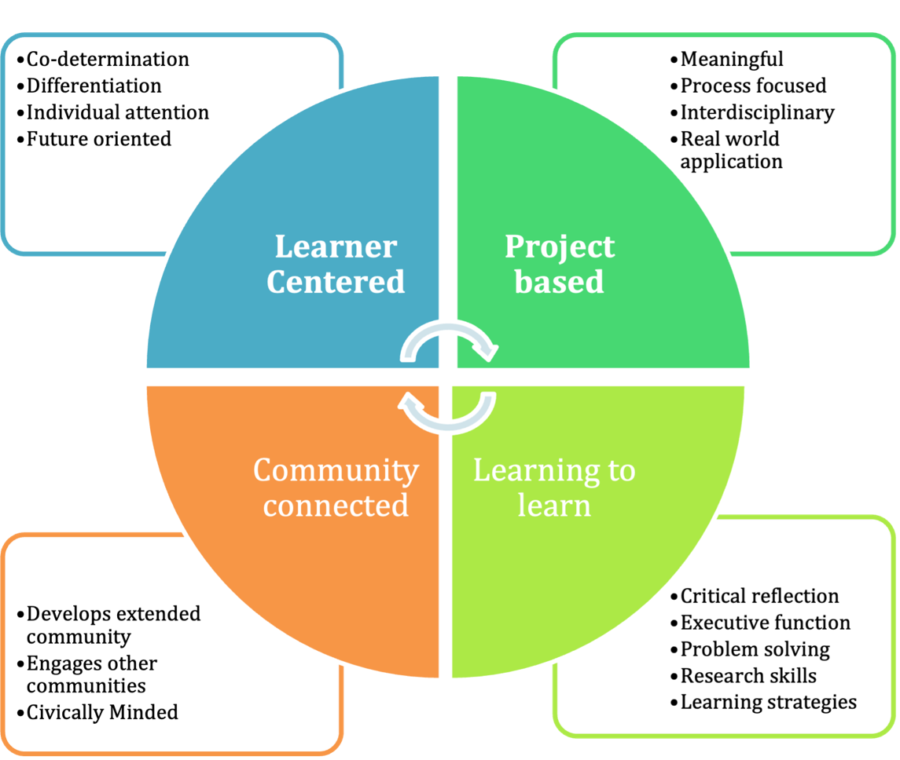

Section 1: Learner centered
The Art-practice classroom is learner centered. Learner centered-ness includes co-determination, differentiation, individual attention, and future orientation.
Decisions about what we learn and how we learn should be co-determined by teacher and student. Ben Volta and Pepòn Osorio worked with their collaborators to make decisions about what was made and why. Paulo Freire writes “a pedagogy (which) must be forged with not for the oppressed.” In the classroom context, the students are the oppressed and the teacher is an ally or resource. In a school this means that the determinations of what and how to teach are made by the teacher and the students. Freire states “the starting point for organizing the program content of education or political action must be the present, existential, concrete situation, reflecting the aspirations of the people”. A curriculum simply imposed on students does not lead to learning outcomes that are as long lasting or impactful as curriculums where students have a voice. A co-determined curriculum provides authenticity for students and teachers.
The Art-practice classroom is also a place of creative production for students. The teacher provides the space, the materials, the resources, the connections and the questions, the student does the work. As educator Christopher Emdin states, “the teacher needs to approach each student collaborator with the intent to be a coordinator of the work to be done as opposed to the foreman.” The teacher as coordinator of work rather than boss also encourages self-pacing of work. When the student is allowed to work at their own pace, they feel more confident in the learning process.
Differentiation in the context of the Art-practice classroom is an essential element. Each individual in the classroom environment must be met where they are in their development. The curriculum should be fitted to each students’ goals and needs. In what Emdin calls “reality pedagogy,” the participant is met at their individual starting point and the trajectory of that individual is determined cooperatively. The coordinator becomes the learner about the participant and their context while the participant is the expert. This approach to working creates a space where participants are intellectually, psychologically, and emotionally recognized and are most likely to take on challenges and grow.
As Pepòn Osorio took his time and built rapport with the Bobcats, so should all Artist-teachers. Any classroom must have a foundation of trust, safety, and mutual respect in order to be most effective. These elements must be worked for and are every bit as important (if not more) than lesson objectives. Treating every member of your classroom as a human being and engaging with them as individuals is of the utmost importance to the Art-practice classroom. Paulo Freire said “dialogue (read: learning) cannot exist, however, in the absence of a profound love for the world and for people.” Getting to know students and spending one-on-one time with each individual is crucial to their education. Each student learns a little differently and has different interests. Understanding them and learning what each student needs and wants allows us as Artist-teachers to better our craft.
In the learner centered Art-practice classroom it is important to face the future and the potential that the future holds. This forward-looking practice includes what educator Bettina Love calls “freedom dreaming.” Freedom dreams are “﻿intentions for love, peace, liberation, and joy.” In the Art-practice classroom, this type of future creating imagining helps to guide students in what type of learning they want to do and what kind of world they want to create for themselves. Students who are engaged in imagining a future for themselves can direct effort toward creating that future.

Section 2: Project based
The Art-practice classroom is project based. Projects need to be meaningful, process-focused, interdisciplinary, and have real world applications. Most art classes are project based and provide some connection to other disciplines and the real world; however, they barely scratch the surface of their potential for these things. They also often lack meaning for students outside of the creative play involved in creation.
In ReForm, Pepòn Osorio engaged with students who were directly affected by the closing of the school and that direct connection made the work on the project meaningful to them. So often in the classroom I heard “when am I ever going to need this?” These statements point to a curriculum disconnected from students and their realities. When I taught projects that connected directly to my students as people it increased their interest levels and engagement. According to Freire “Students, as they are increasingly posed with problems relating to themselves in the world and with the world, will feel increasingly challenged and obliged to respond to that challenge.”
The Art-practice classroom requires an interdisciplinary approach to learning. In Volta’s projects he connected art to science and artists to scientists. In the case of Micro to Macro, in partnership with the classroom teacher, the students were having difficulty learning how to use rulers, so Volta aided by engaging the students by drawing trees with rulers, where the branches get smaller using measurements. Adding a creative aspect to a task that may otherwise seem daunting enabled students to approach it with more confidence. Using rulers and measurements is a skill that is used in many aspects of life, not just in math, science or art. Making the creative connection helps to demystify the learning process to students, answering the age-old question “why do we have to learn this?”
Through these connection Volta is expanding the relevance of a mural project beyond making a visual work. Freire says, “Authentic thinking, thinking that is concerned about reality, does not take place in ivory tower isolation, but only in communication.” No subject should be approached without connection to others and the world. The teacher in this type of classroom makes the connections to other teachers, subjects, community resources and beyond. The process of critical reflection, critique and refinement are necessary in every artist’s practice and in every teacher’s practice. The classroom is not a vacuum. The world is always changing, and the classroom must as well.

Section 3: Learning to learn
Current studies on education are calling for a style of education that engages critical thinking and creative methodology. Most people in the US have information available at any moment. We have easy access to facts, technology, and calculators. What people don’t always have access to is the ability to discern truth from “alternative facts” or the creativity to apply what is known in a new or more relevant way. Paulo Freire’s “problem posing” education model, among others, can help to build and access the criticality and creativity that is necessary in our quickly changing world.
Ben Volta’s creative process with students is one example of the application of this type of education. By centering the knowledge and curiosity of the students he works with he is encouraging them to think critically and engage in problem solving in a way that is frequently absent from their educational lives. This is key to creating a sense of purpose and ownership over one’s own education. According to Freire engaging students in critical thinking and building connections between themselves and the world around them should be a main goal of education. The process of working with students in a critically engaging manner encourages students to think critically in other aspects of their lives and become more creative thinkers in the long term. Volta is also engaging students in a collaborative process. Two heads are better than one, but 30 heads are hard to collaborate with. Introducing democratic methods of collaboration to young people in a low risk, high interest situation will help to develop response to diversity, community mindedness and their own voice. These are the skills necessary for critical engagement and development of our society.
The work of making connections between art and the experience of students is a major aspect of Volta’s process. Beginning the process with brainstorming what students know, students are encouraged to recognize that their own experiences are of value. Too often in school and in life students are considered unknowing. In reality, they are experts in their own experiences. Students have interest and curiosity which is often squashed in schools using the banking method of education. The banking method considers the student to be an empty vessel and the teacher to be the imparter of knowledge, completely discounting that what the student knows is essential in navigating their own world. By accessing this essential knowledge, Volta creates an environment and work that are relevant to students and more engaging. Volta also follows what the students are engaging in and what they aren’t; if the trees or the trains aren’t creating the right energy, he tries something else. By following the lead of the students and not forcing an agenda the group is engaging in a process that will create a worthwhile learning experience for all members of the group.
At each point of departure, the students are doing research about the topic. In We are all Neurons, students researched the role of graffiti on the subways and graffiti culture. They researched the structure of the brain and the structure of a neuron. Perhaps the most important research was the experimentation in creating. While engaging with the neurons that they had drawn, students worked in pairs to make color choices on the computer and then had to defend and discuss their choices to one another.

Section 4: Community Connected
The greatest resource a community has are its members. A school community is made up of students, teachers, staff, parents, grandparents, local organizations, businesses, local libraries, and neighbors. Each classroom has a wealth of resources, for materials, for expertise and other types of support, in their immediate community. Acknowledging and accessing these resources can provide a class with rich and meaningful context and content for learning. This type of community approach is, in creative placemaking terms, asset based. Building an Art-practice classroom requires learning about the place, history and culture of the location. Taking cues for Creative Placemaking, about using the expertise a community has about itself and in itself is key to creating long-term relationships. In each interaction a connection is formed and can lead to others. An Artist-teacher needs to do their homework and be culturally competent. Cultural competency according to the American Psychological Association is “the ability to understand, appreciate and interact with people from cultures or belief systems different from one's own.” Cultural competency is a key to working in any teaching context. It is imperative to acknowledge differences in culture and to value the diversity of opinion, position and viewpoints which come with these differences. An educational environment which seeks to be a democratic setting should “celebrate diversity, welcome dissent and rejoice in collective dedication to truth.”
In addition to the immediate community that an Art-practice classroom belongs to it is important to connect with other communities. Connection to various other types of communities, including professional, educational, and global communities broadens the experience of students and deepens connections to the learning that is happening. In Micro to Macro, Volta connected with a neuroscience lab at MIT to learn about the electron microscope and powers of magnification. Each aspect of each project uses connections to the real world guided by the interest of the students and using resources from outside the group. Volta said, “we're the artists here, but we're not necessarily the scientists or we're not the experts” and making the connection to the experts is a necessary part of the learning and the creative process.
It is important that the Art-practice classroom be civically minded as well as community minded. One of the main goals of education according to John Dewey is “The fundamental method of social progress and reform.” In order to prompt progress and reform students need to engage with real issues and civic process. As in ReForm, where students learned about the School Reform Commission and the process through which their school was closed, students need to learn how current systemic structures are set-up. The Art-practice classroom should encourage students to find out why things are the way they are in order to come-up with new ways of doing things which are just and equitable. An education which does not include civic education continue to reproduce dominant ideology.

Conclusion

﻿“Teaching strategies and education reform models must offer more than educational survival tactics to dark children—test-taking skills, acronyms, character education, No Child Left Behind, Race to the Top, charter schools, school choice. They need to be rooted in an abolitionist praxis that, with urgency, embraces what seems impossible: education for collective dignity and human power for justice.” -Bettina Love

To create an environment in which critical engagement occurs, the Art-practice classroom requires planning for the physical space, the emotional space, community building, and community engagement. If the goal for this type of education is to allow students to explore the world around them and create new experiences, then the environment must be geared to reflect that goal. Artist and educator Christopher Banks Carr calls his version of this type of space “the Philosophy Room,” adding that it is a space for “cultivating and encouraging students and teachers to take subjects, ideas and concepts that come up in their coursework and have a space to literally play with them.”
Generally, we are not given a choice as teachers as to the physical structure in which our work will take place. I have been assigned all sorts of classrooms in my career and I have had to make do with what I was given. What a teacher does have control over, to a much greater degree, is the way their space looks and is laid out. Traditional classrooms place students, in single seats and desks in rows facing front. One of the well-known texts for beginning teachers recommends “it is wise to begin the school year with desks in rows facing the teacher.” This structure does not work well in the art room for a number of reasons but would be even less conducive to work in an Art-practice classroom.
In an Art-practice classroom, furniture and seating would be arranged according to current need. There would be a variety of workspaces, tables, desks, work benches and floor space. There would be multiple types of seating, desk chairs, stools, cushioned chairs, and bean bag chairs. The basis of the space would be to cover the broadest set of explorations possible in one space. There would need to be computers, laptops, printers, drawing materials, painting materials, printing materials, books, sculpting materials, drafting supplies, tools, building materials, etc. The larger the space the more types of exploration possible. But in a limited space, the most important tool is access to community resources and community experts.
Having taught in traditional school environments I recognize the seeming impossibility of what I have proposed. The conditions would have to be ideal for this type of classroom to exist in current educational structures. There are a few schools that have engaged with some, even most, of the proposals outlined in this framework. These schools work because the entire school structure and school community support the type of education that they provide.
What I am proposing, is a classroom that exists in a traditional setting but functions differently than a traditional classroom. Using my last Philadelphia school as a reference point, I will describe what it would take to make the Art-practice classroom possible.
The administration of the school would have to support this type of education. The school principal, the school-based teacher leader and the counselor would need to acknowledge that the current school system is flawed. They would have to recognize the importance of systemic change and understand that it needs to start somewhere. The school administration would have to support the work that the Artist-teacher is doing in their classroom, even if it doesn’t look like what they are used to. The administration would have to recognize the professionalism of the Artist-teacher as an educator.
Most schools and districts require teachers to turn in a syllabus and 2 weeks of lesson plans at the beginning of the school year and every 2 weeks after that. In the Art-practice classroom the syllabus and lesson plans would look different. They would not have subject specific recall-based objectives. Lesson plans and syllabi would consist of themes, timelines, questions, work plans, and goal setting work. Each teacher and student would be creating their own research goals and course objectives as a part of their self-directed learner centered curriculum. Objectives, plans and goals would be generalized and be determined over the course of the semester. This of course means that the administration would have to be flexible with expectations for course planning when it comes to the Art-practice classroom.
Class scheduling would need to be creative and flexible. The Art-practice classroom needs the ability to work with smaller class groupings and extended class time to provide enough one-on-one interaction and time for project work. The Artist-teacher would also need enough planning time and resources to make calls, visits, and connections in the local and broader community. The Artist-teacher would have to commit themselves to the extended time and effort necessary to create an ever-changing program.
To put this entire framework into action at once in one location may be a long shot. Having been a teacher in a large district which is more concerned with test performance and statistics than it is with the actual needs of the students I realize that this approach to teaching will be difficult to achieve. The large class sizes (30+ students), limited resources (financial, human, and material) and the diversity of student population (cultural, developmental, and educational) in traditional schools make an Art-practice classroom sound even more daunting. It may be necessary to take this change incrementally, as Bettina Love puts it in her book about abolitionist teaching:
“﻿It seeks to resist, agitate, and tear down the educational survival complex through teachers who work in solidarity with their schools’ community to achieve incremental changes in their classrooms and schools for students in the present day, while simultaneously freedom dreaming and vigorously creating a vision for what schools will be when the educational survival complex is destroyed.”

With the goal of abolishing the “educational survival complex” in mind, this framework dreams of a more individualized approach to the classroom where student success is not contingent upon test scores, but on finding a path to the students’ own idea of success. My framework, and my pledge aim to create an environment open for individual expression, inquiry, equity, and joy. I hope that continued reflection on my own practice, positioning, and privilege in relation to my role in the education system will guide me in creating an environment where my students will thrive.

Bibliography

Allen, Felicity. Education. London: Whitechapel Gallery, 2011.
Bain, Ken. What the Best College Teachers Do. Cambridge MA: Harvard University Press, 2004.
Bishop, Claire. Artificial Hells: Participatory Art and the Politics of Spectatorship. London: Verso Books, 2012.
Clark, Robin E. “Where Community Happens.” Beyond the School: Community and Institutional Partnerships in Art Education, edited by Rita L. Irwin and Anna M. Kindler, 5-13. Reston, VA: The National Art Education Association, 1999
Cook, Justin W, ed. “Sustainability, Human Well-Being, and the Future of Education.” The Finnish Innovation Fund, 2019. https://doi.org/10.1007/978-3-319-78580-6.
Dewey, John. Art as Experience. Kindle ed. New York, NY: Putnam, 1980.
Dewey, John. My Pedagogic Creed. Nabu Press, 2010.
Emdin, Christopher For White Folks Who Teach in the Hood… and the Rest of Y’all
Too, Beacon Press Boston, 2016
Frasz, Alexis, and Holly Sidford. “Mapping the Landscape of Socially Engaged Artistic Practice.” Art making Change. Helicon Collaborative, 2017. http://artmakingchange.org/wp-content/uploads/2017/09/Mapping_the_Landscape_of_Socially_Engaged_Artistic_Practice_Sept2017.pdf.
Freire, Paulo Pedagogy of the Oppressed, 30th anniversary edition, Continuum
International Publishing, NY 1970/2000
Gordon, David, Anne Meyer, and David Rose. Universal Design for Learning. Wakefield, MA: CAST Professional Publishing, 2016.
Helguera, Pablo. Education for Socially Engaged Art. Jorge Pinto Books Inc., 2012.
Kindle edition

hooks, bell Teaching to Transgress. NY: Rutledge, 1994
Kocur, Zoya, and Simon Leung. Theory in Contemporary Art since 1985. Chichester, West Sussex: Wiley-Blackwell, 2013.
Love, Bettina. WE WANT TO DO MORE THAN SURVIVE: Abolitionist Teaching and the Pursuit of Educational Freedom. S.l.: BEACON, 2020.
Madoff, Steven Henry. Art School: (Propositions for the 21st Century). Cambridge, MA: MIT Press, 2009.
Santamaria, Lorri J. “Culturally Responsive Differentiated Instruction: Narrowing Gaps Between Best Pedagogical Practices Benefiting All Learners.” Teachers College Record 111, no. 1 (January 2009): 214–47.
Sholette, Gregory, and Chloë Bass. Art as Social Action: An Introduction to the
Principles and Practices of Teaching Social Practice Art. New York, NY: Allworth Press, An Imprint of Skyhorse Publishing, 2018.

Thompson, Nato (2012). Living as Form, Socially Engaged Art from 1991-2011.
Cambridge: MIT Press
Ward, Henry. “Teaching as An Artistic Practice.” Dissertation, Middlesex University, 2013.
Warren, Mark, “School Closing and Community Openings”, ReForm, Temple Contemporary 2016: 55-68 Cornerhouse, Manchester, UK
Wilson, Risë “Hide and Seek: In Search of Reform,” in Pepón Osorio, ReForm (Philadelphia: Temple University, 2016), pp. 27-37
Woolard, Caroline. “Projects, Platforms, and Practices Framework.” Author, April 2018.

Interviews

Kester, Grant Transcript of the entire interview by Martin Krenn with Grant Kester, 10th
December 2013, Belfast/San Diego
Murch, Lisa (Director of Art Education, Mural Arts) in discussion with the author,
September 2020
Osorio, Pepòn. Interviewed by Emily Elliott. Phone interview, November 12, 2020

Volta, Benjamin (artist) in discussion with the author, September 2020

Websites
“Benjamin Volta: Mural Arts Program: CreativeMornings/PHL.” CreativeMornings, October 14, 2014. https://creativemornings.com/talks/ben-volta.
Bruguera, Tania. “Tania Bruguera: Artist Statement.” tania Bruguera | Artist Statement, 2009. http://www.taniabruguera.com/cms/395-0-Artist+Statement.html.
Carr, Christopher Banks. “The Philosophers Room.” CURATING THE CLASSROOM, February 13, 2019. https://curatingtheclassroom.org/saason/.
DeAngelis, Tori. “In Search of Cultural Competence.” Monitor on Psychology. American Psychological Association, March 2015. https://www.apa.org/monitor/2015/03/cultural-competence.
Glavin, Chris. “Critical Pedagogy.” Critical Pedagogy | K12 Academics, February 6, 2014. https://www.k12academics.com/educational-philosophy/critical-pedagogy.
“Graduate Fine Arts.” Graduate Fine Arts | Weitzman School. Accessed March 21, 2021. https://www.design.upenn.edu/fine-arts/graduate/people/ernesto-pujol.
Grady, Elizabeth. “Pepón Osorio: The Impact of ReForm.” FIELD, 2018. http://field-journal.com/issue-9/pepon-osorio-the-impact-of-reform.
Helguera, Pablo. “Transpedagogy.” s3.amazonaws.com, n.d. https://s3.amazonaws.com/arena-attachments/75021/helguera_transpedagogy.pdf.
“Interdisciplinary.” Merriam-Webster. Merriam-Webster. Accessed February 21, 2021. https://www.merriam-webster.com/dictionary/interdisciplinary.
“Micro to Macro.” Mural Arts Philadelphia, January 10, 2018. https://www.muralarts.org/artworks/micro-to-macro/.
“Performance/Installation.” SUZANNE LACY. Accessed November 21, 2020. https://www.suzannelacy.com/performance-installation#/the-oakland-projects/.
“Project.” Philadelphia Assembled. Philadelphia Museum of art, 2017. http://phlassembled.net/project/.
Pujol, Ernesto. “The Listeners.” The Brooklyn Rail, December 8, 2018. https://brooklynrail.org/2018/12/1by1/The-Listeners-Ernesto-Pujol-2018.
Rabin, Sarah, Georgina Achilles, Sarah Page, and Christopher Koliba. A Brief Overview of Progressive Education, September 6, 2002. http://www.uvm.edu/~dewey/articles/proged.html.
“SEPTA Mobile: ‘We Are All Neurons’ Aims to Educate & Entertain Riders' Brains along the Market Frankford Line.” SEPTA Mobile | "We are all Neurons" aims to educate & entertain riders' brains along the Market Frankford Line. Accessed November 21, 2020. http://www.septa.org/m/media/short/2013/12_5.html.
Tate. “Relational Aesthetics – Art Term.” Tate. Accessed February 21, 2021. https://www.tate.org.uk/art/art-terms/r/relational-aesthetics.
Tate. “Socially Engaged Practice – Art Term.” Accessed February 21, 2021. https://www.tate.org.uk/art/art-terms/s/socially-engaged-practice.
Volta, Ben. “We Are All Neurons.” volta. Accessed November 21, 2020. http://www.benvolta.com/we-are-all-neurons.
“What Is Artistic Practice.” IGI Global. Accessed February 21, 2021. https://www.igi-global.com/dictionary/artistic-practice/47005.
Wolensky, Meg. “Mural Arts Goes from Macro to Micro with Ben Volta and Gerald Lopez.” Mural Arts Philadelphia, September 23, 2016. https://www.muralarts.org/blog/mural-arts-goes-macro-micro-ben-volta-gerald-lopez/.
Zeleznik, George. “Encouraging Critically Engaged Citizens: So What?” NAIS, 2011. https://www.nais.org/magazine/independent-school/spring-2011/encouraging-critically-engaged-citizens-so-what/.

Illustrations
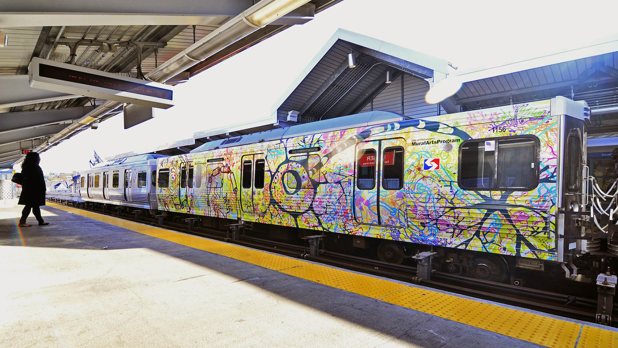
    - Volta, Ben We Are All Neurons, photo by Damon Landry https://www.muralarts.org/artworks/we-are-all-neurons/

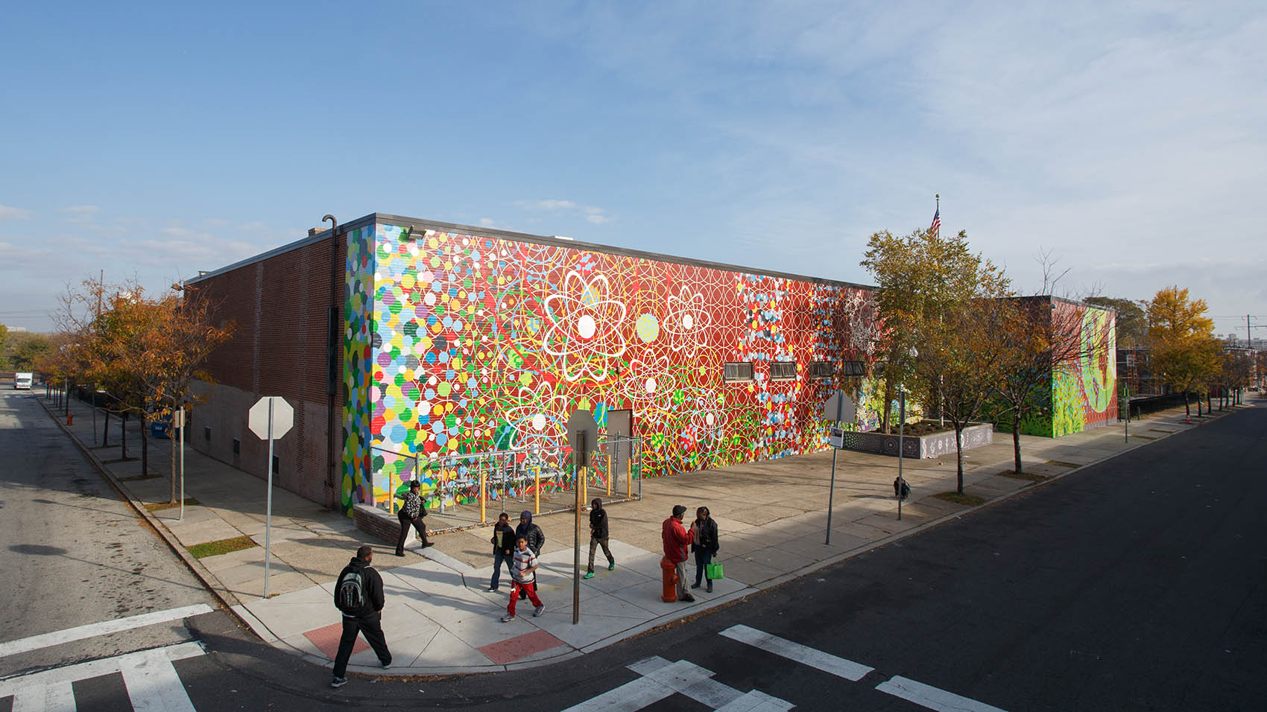
    - Volta, Ben Micro to Macro, photo by Steve Weinik https://www.muralarts.org/artworks/micro-to-macro/
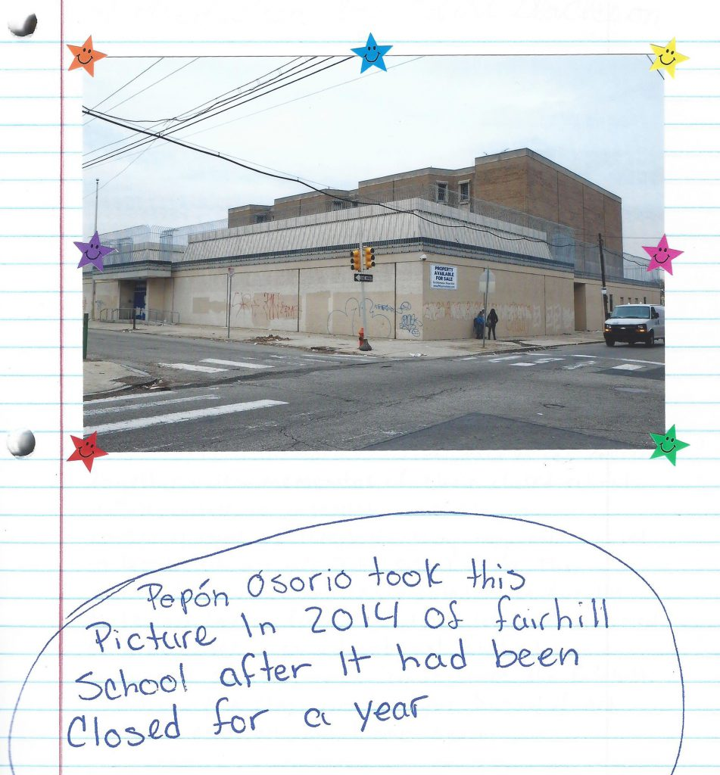
    - Pepón Osorio took this picture in 2014 of Fairhill School after it had been closed for a year. ReForm (Philadelphia: Temple University, 2016), this image, p. 5
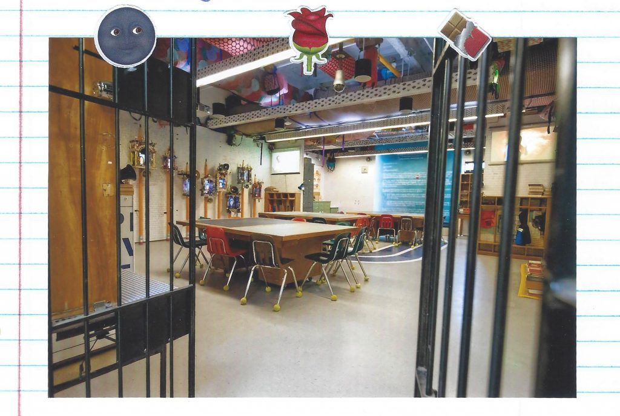
    - Installation view, ReForm, Tyler School of Art, 2015-16, p. 54
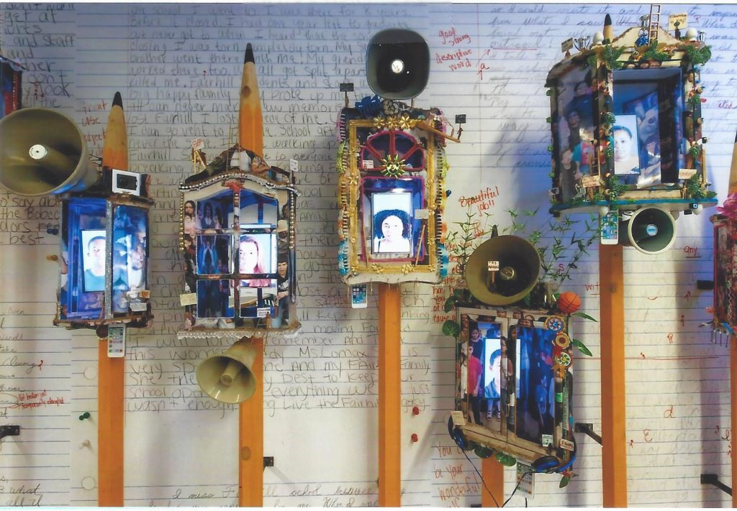
    - Installation view, ReForm, Tyler School of Art, 2015-16, p. 32
Artifacts/appendices:

The Framework
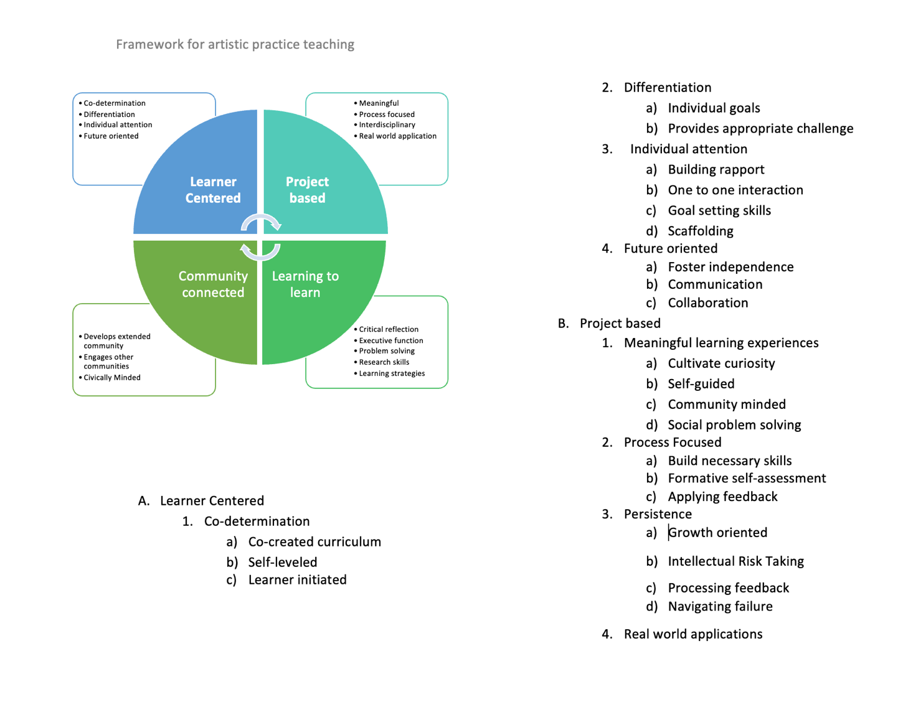
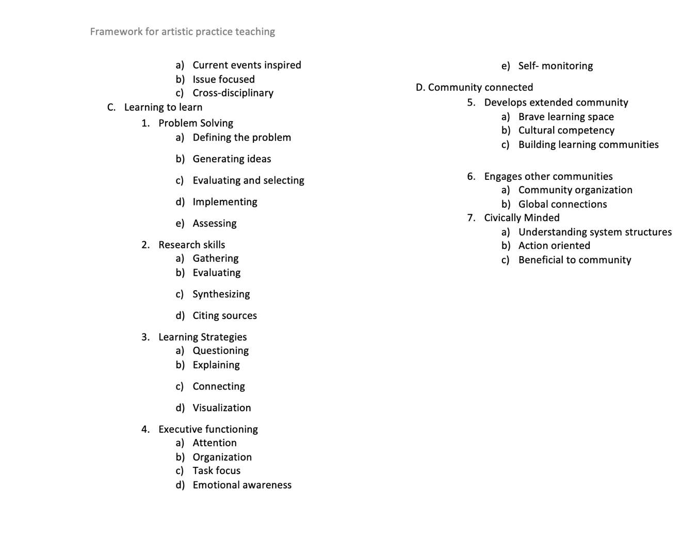

II. My pledge
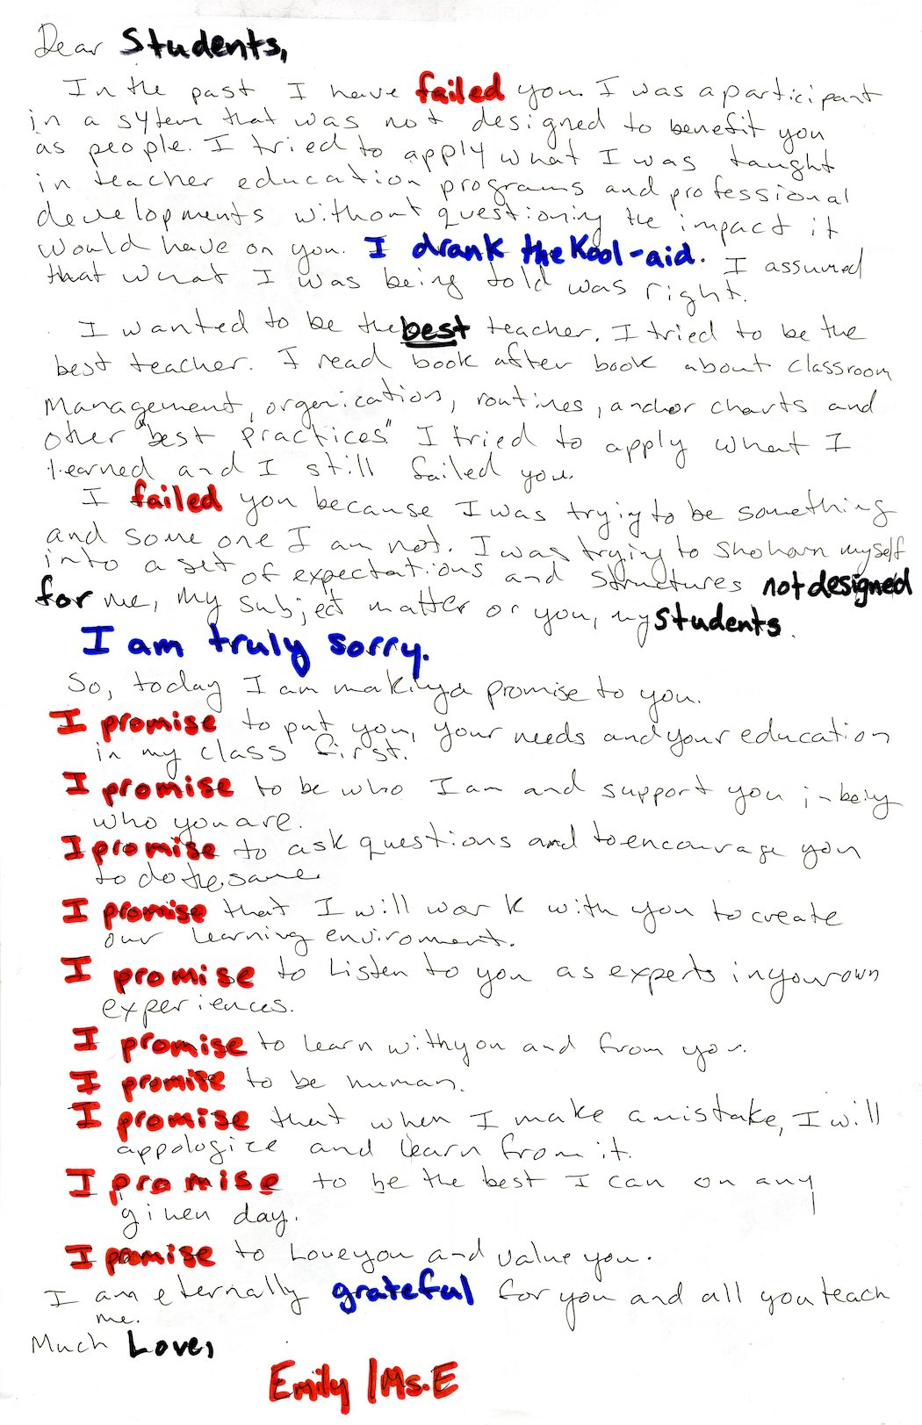

Case studies

Case Study #1
Ben Volta:
We Are All Neurons and Micro to Macro
As a certified K-12 art teacher in the school district of Philadelphia I found that the delivery methods I used in the classroom were not in line with my pedagogical beliefs. I believe in problem solving, personalized education. What I was doing in my classroom was a model that Paulo Freire refers to as the “banking method”, where students are empty vessels in which information is “deposited”. This model of education is historically the dominant form in most traditional schools and, according to Freire, is one the biggest tools of oppression of the dominant culture.
My complicity in this domination and oppression goes against my core beliefs and my teaching philosophy. I was raised by educators who were both creative in their methods in the classroom and supportive of inquiry at home. My early schooling was in a typical suburban public school whose methods were dominated by the “banking” theory. I didn’t do well in this environment, I felt that I learned better and more on my own and in relation to my interests. I was first exposed to progressive education in high school. It was the first time that my interests mattered in my education. My experiences in school led me to pursue teaching as a career path and to form a teaching philosophy which centers student voice. The reality of teaching in a large city school district led me to fall into a pattern of teaching which was based on the desires of the administration. This, among other factors, led me to quit teaching and return to school for my graduate degree.
Through my research in my MFA program, I returned to my roots and began looking at modes of socially engaged art that center the voice of the participant, rather than the voice of the artist. I am also interested in the idea of relational aesthetics, which is a theory of Nicolas Bourriaud “A set of artistic practices which take as their theoretical and practical point of departure the whole of human relations and their social context, rather than an independent and private space.” (pg. 113). In other words, art is what happens in the process of making and the relation of humans, one to another. The questions I am asking in this case study are:
- Can the art classroom be a space of relational art?
- How are issues of power addressed in collaborative art making, specifically with students?
- How are issues of authorship addressed?
My interest in student centered creative processes and my interest in using these processes in the school environment led to my introduction to Ben Volta.
I had the great fortune of having a (virtual) studio visit with Ben in the spring of 2020. We discussed my work, his work with Tim Rollins and Kids of Survival, and his work with Mural Arts. Our conversation led me to pursue new ways of connecting with people for art making and served as the foundation for this case study.
Information in the case study was gleaned from several methods. Interviews with Ben Volta and the director of Art Education at Mural arts, Lisa Murch, content analysis of publicly available digital content and review of relevant literature. I also referenced videos of Volta speaking at events, his website, the SEPTA online archive and the Mural Arts website.
Results:
I chose to focus on the work of artist Ben Volta in his role as a teaching artist with Mural Arts in Philadelphia. The two projects which are the focus of this study are addressed separately in the follow sections.
We Are All Neurons, 2013
The project We Are All Neurons was a collaborative project initiated by Mural Arts and artist Ben Volta in 2013. What started as an off the cuff remark to Jane Golden, founder and executive director Of Mural Arts, became a moving mural in the form of a wrapped SEPTA subway car on the Market -Frankford line. In partnership with SEPTA, Mural Art’s LEAPs Program and Waring Elementary, 27 students, 4 assistants and artist Ben Volta, worked for two and a half months after school to create the design for the wrapped subway car. Inspired by President Obama’s Brain initiative, the artists explored the connections inside the brain and the connections made through the subway line. The final work that wraps the train is a series of neurons drawn by the students, colorized, and overlapping. The interior of the train has an explanation and images of the creative process.
The Market-Frankfort line runs from the heart of North-East Philadelphia through Center City and out to South-West Philadelphia’s 69th Street transportation hub. Thousands of people ride this line to get to work, school or entertainment venues every day. Trains on this line run from 4:40 AM to midnight on weekdays and 24 hours on weekends. This transit line is essential in the city, allowing people from distant parts of the city to access the city center and beyond. While the choice of the line was up to SEPTA, Volta began his design work by discussing the role this transit route plays in the city. While the impact to the riders of the Market-Frankfort line is up for some discussion, the impact on the creators of We Are All Neurons can be stated with some certainty. The 3 participants interviewed at the unveiling event all learned from the process of making the mural as did Volta.
Micro to Macro, 2014
Over the course of 14 months Ben Volta partnered with Morton McMichael Public School in the Mantua section of Philadelphia to create a 12,000 square foot mural which covers 3 faces of the school building. With funding from PECO, Philadelphia Department of Human Services and the Lindy Family, Mural Arts was able to pilot what would become their Arts Integration program.
Volta started out sitting “as a student” in the 7th grade science and math classes at McMichael to find out what the students and teachers needs were and then help find creative connections. From the beginning of the project, Volta knew that the product would be a mural on the school building, and that his role was to facilitate the process of creating the content of the mural. The mural was requested by the school administration to cover the facade and make it more welcoming. During the 14 months at McMichael the process involved an average of 50 students per week, both during math and science class and in the self-selected after school program at McMichael School. The mural begins with a magnified view of atoms, molecules, and DNA through synaptic connections at the entrance and moves to a life-sized view of trees then zooms out to show the Earth from space, the galaxy, and the sun. The image lightens the school building and creates a more welcoming environment, but according to Volta the impact is in the experience of the students who participated.
Discussion:
Ben Volta’s process when working with students is adapted from his experience working with Tim Rollins and the Kids of Survival (KOS) in the early 2000s. According to Volta the process with KOS was conversational and organic. The group worked from a text, talked about it, and found where they connected to it and then began making art in response to those connections. Volta’s process is similar but instead of text, in these instances, he began with the context in which he was working, the train in the case of We are all Neurons and the science and math classes in the case of Micro to Macro. In each case he presented the students with a problem to be solved, wrapping a train with a moving mural, and creating a mural on the school. “Problem-posing” education is Paulo Freire's solution to the oppressive “banking” system of education. According to Freire (and many other educational scholars) engaging students in activities that engage critical thinking and build connections between themselves and the world around them should be a main goal of education. The process of working with students in a critically engaging manner encourages students to think critically in other aspects of their lives and become more creative thinkers in the long term.
According to Volta each conversation “started with only the goal of making something together”. The artist brought no ideas himself but added to the conversation as they went along. By allowing the natural flow of the conversation and adding connections Volta was encouraging students to claim ownership and authorship of the work. Each group began the process by brainstorming what they did know, instead of trying to discover what they didn’t know. People know a lot more than they realize, especially children. Connecting what folks do know with a new process reinforces learning and engages metacognition (learning how to learn).
For We are all Neurons the process began with sketching tracks and connecting them while talking about what a train does. Following the thread of the conversation led to talking about how the brain makes connections and eventually to drawing neurons. They drew a lot of neurons in different styles and line qualities, over and over again until the students had covered a wall with them. The process of sketching encourages more detailed thinking and develops new ideas and skills. The low-risk nature of a sketch encourages students to try things that they wouldn’t try if it were their “good copy”. Sketching and repetition build confidence in a new skill or content and trying different styles keeps the subject from getting stale. Then the act of putting all the sketches together on the wall builds a sense of accomplishment and pride in the work of the group.
In the case of Micro to Macro, in partnership with the classroom teacher, the students were having difficulty learning how to use rulers, so Volta aided by engaging the students by drawing trees with rulers, where the branches get smaller using measurements. Adding a creative aspect to a task that may otherwise seem daunting enabled students to approach it with more confidence. Using rulers and measurements is a skill that is used in many aspects of life, not just in math, science or art. Making the creative connection helps to demystify the learning process to students and answer the age-old question “why do we have to learn this?”
The work of making connections between art and the experience of students is a major aspect of Volta’s process. Beginning the process with brainstorming what students know, students are encouraged to recognize that their own experiences are of value. Too often in school and in life students are considered unknowing. In reality they are experts in their own experiences. Students have interest and curiosity which is often squashed in schools using the banking method of education. The banking method considers the student to be an empty vessel and the teacher to be the imparter of knowledge, completely discounting that what the student knows is essential in navigating their own world. By accessing this essential knowledge Volta creates an environment and work that are relevant to students and as such more engaging. Volta also follows what the students are engaging in and what they aren’t; if the trees or the trains aren’t creating the right energy, they try something else. By following the lead of the students and not forcing an agenda the group is engaging in a process that will create a worthwhile learning experience for all members of the group.
At each point of departure, the students are doing research about the topic. In We are all Neurons students researched the role of graffiti on the subways and graffiti culture. They researched the structure of the brain and the structure of a neuron. Perhaps the most important research was the experimentation in creating. While engaging with the neurons that they had drawn, students worked in pairs to make color choices on the computer and then had to defend and discuss their choices to one another. In Micro to Macro Volta connected with a neuroscience lab at MIT to learn about the electron microscope and powers of magnification. Each aspect of each project uses connections to the real world guided by the interest of the students and using resources from outside the group. Volta said, “we’re the artists here, but we're not necessarily the scientists or we're not the experts” and making the connection to the experts is a necessary part of the learning and the creative process.
Conclusion:
Current studies on education are calling for a style of education that engages critical thinking and creative methodology. Most people live in a world where information is available at any moment. We have easy access to facts, technology, and calculators. What folks don’t always have access to is the ability to discern truth from “alternative facts” or the creativity to apply what is known in a new or more relevant way. Paulo Freire’s “problem posing” education model, among others, can help to build and access the criticality and creativity that is necessary in our quickly changing world.
Ben Volta’s creative process with students is one example of the application of this type of education. By centering the knowledge and curiosity of the students he works with he is encouraging them to think critically and engage in problem solving in a way that is frequently absent from their educational lives. This is key to creating a sense of purpose and ownership over one’s own education.
Volta is also engaging students in a collaborative process. Two heads are better than one, but 30 heads are hard to collaborate with. Introducing democratic methods of collaboration to young people in a low risk, high interest situation will help to develop response to diversity, community mindedness and their own voice. These are the skills necessary for critical engagement and development of our society.
While Volta’s process is well developed and his results are undeniable, there are several questions that remain to be addressed:
- Are the techniques used transferable to all types of participants? According to Volta, his methods are most successful with students of middle school age. When he began working with high school age students, he found them far more reluctant and difficult to engage.
- Is it possible for the artist to keep his own voice out of the work? Volta acknowledges that he amplifies his own voice and vision alongside the voices of the students he works with.
- How can an artist both claim a work and share the authorship? Volta lists the names of all the student collaborators along with his in the by-line. He is also the expert in the field of mural making and art and is credited as such.
- How much agency do the artist and students have in the outcome of a project? There are few factors that guide the product of a specific project. The desires of the owner of the property, the guidelines of the funder for the use of their money and the vision of Mural Arts as an organization.
Volta does not consider his work to be relational art in the sense which Bourriaud defined it, but he does recognize the relational aspects of the process. As I see it, the careful and thoughtful relationship of student to artist and the skill in finding creative connections and encouraging curiosity is the essence of the art of teaching. The art of teaching, when done with the intent to enable the freedom of the learner, is the very essence of relational art.

Case Study #2
ReForm: Pepòn Osorio
Dialogical Practice and Pedagogy
Introduction
From January of 2014 through June of 2019, I was an art teacher in the School District of Philadelphia (SDP). The first school where I taught was Penrose in southwest Philadelphia. The previous spring, 2013, the SDP at the command of the School Reform Commission (SRC) closed 24 schools including Pepper Middle School. In the fall of the 2013-14 school year many of the students from Pepper opted to come to Penrose to finish middle school. This added to already crowded classrooms and created a noticeable cultural shift in Penrose.
I came into Penrose blissfully unaware of this particular change. I knew that the previous year had seen catastrophic closures of schools throughout Philadelphia. I was aware but hadn’t experienced the after-effects firsthand until Penrose. Penrose not only absorbed it’s share of disenfranchised students but also a fair number of teachers from Pepper. Penrose was not the easiest school to come into. It had its own established culture and some teachers who had been in the school for their entire careers. My students often came from families where not only all of their siblings had gone to the school before them, but their parents, their aunts, uncles and in some cases their grandparents. Penrose is a neighborhood school. And so was Pepper, before they closed it. Imagine, going to the same school your whole life and then suddenly, with only a few months warning they close that school and ship you off to another, in another community, with new kids, new rules, new culture. That is what the Pepper kids were dealing with when I started at Penrose. There were problems with the transition. Anytime there was a behavior issue or one of the frequent fights, Pepper kids got blamed. I frequently heard people say “it’s those Pepper kids causing all the problems” or asking why they had to come to “our” school as if they had a choice.
ReForm is a series of projects and events facilitated by artist and educator Pepòn Osorio which approaches the 2013 school closures from the point of view of the community that was dissipated by the SRC decision to close Fairhill School. I was pointed toward this project by several Professors in my MFA program as it related to my passion and interest in education and justice.
My passion for teaching is such that I consider teaching to be my art. My practice is the creation of an environment in which students are motivated to grow and learn and where collaboration bears the fruit of life-long learning. I am engaging in practice which will help give students the tools for continued inquiry and critical engagement in the world. As I approach this study, I am asking the following:
How do artists/teachers create environments in which growth
of the participant is necessary?
Why is art an effective tool in creating growth and change?
When creating relational art with stakeholders how are results measured?
Methods
As part of my research for this study I reference an existing case study by Elizabeth M. Grady. In her study Grady focuses on the impact of the project and it’s longevity. My research runs parallel to hers in many ways and I will be referring to her work in several places. I will also reference interviews with Osorio and one of the student participants from the project. The artist book which accompanied the exhibition and additional publicly available digital content are also used as material for this paper.

Theoretical Frameworks
My lens for examining this project is as an educator and my questions are pedagogical in nature. The philosopher John Dewey knew in 1916 that learning resides in process and experimentation. While educators are still trying to understand this concept, science and artists have known the truth all along; we learn best and most from active experimentation and collaboration (as opposed to rote). Socially engaged artists looking to engage with communities are also aware of the benefits of critical engagement and democratic methods in collaborative work. Paulo Freire, a Brazilian educator, and theoretician, talks about critical engagement of students through “problem-posing education” in which the teacher and students alike are engaged in solution finding and learning from one another. And bell hooks wrote in Teaching to Transgress:
“When education is the practice of freedom, students are not the only ones who are asked to share, to confess. Engaged pedagogy does not seek simply to empower students. Any classroom that employs a holistic model of learning will also be a place where teachers grow and are empowered by the process.”
The same can be said of creative collaborative spaces. In democratic socially engaged art practices the artist is engaging with stakeholders as a learner among learners. The artist should be learning about their co-artists and the community they are joining as they work on a process of mutual benefit. This touches on Grant Kester’s idea of dialogical practice:
“the artist is not always the one “presumed to know,” and the viewer qua participant is able to produce his or her own transformative knowledge. The subject positions, author and recipient of authored material, for example, and modes of agency, fluctuate through the course of a given project.”
Which aligns with Freire-an educational practice in which the teacher is student and student is teacher.
The Project
In 2014, Pepòn Osorio was on his usual route to work as a professor of art at Tyler School of Art in North Philadelphia. He passed by the abandoned Fairhill school every day. The school sat derelict for over a year when he took a picture of the building that sparked a project that would last for 3 years and beyond. Osorio began asking questions about the school and what happened to the community.
Fairhill school had existed in that neighborhood since 1887. Generations of families had attended the school and then in 2013 that was abruptly ended. Students who would have graduated from the K-8 school in the 2013-14 school year were deprived of what was a family tradition for some. Neighborhood schools are a backbone of many communities and they were planned that way. When public education was just a “babe in arms” and schools were being built throughout the city, the sites were chosen to be in the center of the communities that they served. They became hubs for community events, political purposes and voting among other things. Years of teachers and generations of students reinforce a sense of consistency in a community.
When a school closes the effects are beyond the need for students to go to another school. In the words of Mark Warren “The abandoned school building, no longer a symbol of communities ties, now becomes a potent symbol of neighborhood disempowerment and decay” When Philadelphia closed 24 schools in 2013, they were in primarily high poverty, Black and Brown neighborhoods. The SRC cited “low performance” and low enrollment numbers as reasons for closing those particular schools. The Fairhill school is located in a section of Philadelphia that, according to the 2010 census, is 80% Hispanic and has a poverty rate of 61%. Regardless of the “reasons” the SRC closed Fairhill, there is no doubt that the effect of the closing has been significant.
Osorio found out that among the graduate students at Tyler at the time, there was a former Fairhill teacher, Tim Gibbon. Osorio and Gibbon already had a working relationship and so they began having conversations about the school and community.
“What if, what if what if, and then finally, all the what ifs were answered with the idea that I wanted to bring everybody back together. It had been a while since the school was closed, and all the people in the community were completely dispersed. And I wanted to bring them back together, I really wanted to put them back together, somehow, somewhere in the back of my mind, I just want to reunite. That's all I wanted to do and sit them at a table.”
That became the foundation for the first event. A dinner which included teachers, parents, and students from the school. The dinner, which was attended by around 75 (to 150) people, was held at Tyler School of Art, in December of 2014. The dinner, held in the classroom that would come to be the main exhibit space of the installation, was informal and intended as an opportunity for the community to reconnect after a year of being apart.
“As a result of that, I started to spark which I always do, spark in a couple of people and talk to a couple of people … and I sort of like to lock in, like 10 of them, who I thought had potential. And I wanted to work with.”
Thus began the meetings of the “Bobcats” so named because of the school’s mascot. The Bobcats, a core group of 10 former students of Fairhill who met with Osorio every Saturday. At first, they just wanted to get together to socialize but, with the guidance of Gibbon and Osorio, they began to discuss and thin critically about the closing of the school and creating an impactful event. They decided that they would have a “Fun Day”, an event which the school held every year for students, their families and community members.
Fun Day was held on May 1, 2015 and 800 people showed up. The Bobcats produced the event with the help of Osorio and students from Tyler for logistics and printing. The event included face painting, carnival type games, music, a piñata shaped like the school district building and speeches from various members of the Fairhill family. Each station was planned and attended by a Bobcat or another former student. While the event was taking place, Osorio and students from Tyler had gotten permission from the SDP to go into the derelict school building and remove object and furniture for the installation being planned at Tyler.
The installation was the result of collaboration between the Bobcats and Osorio’s team. Osorio would have an idea and then run it by the Bobcats for approval and then it happened. Osorio had gotten the Bobcats summer jobs as his assistants on the installation. So, they spent the summer putting the piece together.
The installation itself, a life size interpretation of the life of Fairhill opened in August of 2015 and ran through may of 2016. The installation was open from 12-5 Thursday through Sunday, hours set to ensure that one of the Bobcats was on site to guide visitors through the exhibit. The installation begins in the hallway entering the basement at Tyler, with a row of cubbies, taken from Fairhill along with the real abandoned belongings of students that fill them. Above the cubbies is a timeline of pictures that illustrate the life of the school. Also in the hallway, before you get to the main exhibit space, is a water fountain, also taken from the school, and marked with the (all too familiar and real) “DO NOT DRINK THE WATER” warning that accompanies many water sources in the SDP. Almost all of the artifacts, including the inhaler hanging next to the water fountain, were taken from the school building on Fun Day. The classroom you enter you are greeted by a life-sized photograph of the principal from Fairhill on the door, you walk through the metal gates that adorn actual classrooms in SDP into the installation which includes tables, chairs and chalkboards, cubbies, books, and posters from the classrooms of Fairhill. The walls are hung with writing of the Bobcats, marked, and corrected in red pen by former teachers. There is a video playing on a projector screen of a Bobcat in a white tank top and baseball hat writing on a chalkboard “Do I have to die for things to change?”. Lining one wall are 12 “shrines” mounted on giant pencils with video of each Bobcat reciting in unison a poem written by Bobcat Chelsea Velez called “When WE Speak You Listen” on repeat.
This work did not end with the creation of the installation. The work of ReForm continued with meetings of the Bobcat’s every weekend working with Osorio and Gibbon on different aspects of civic engagement interests that the student’s became involved in. The student’s created models of the members of the SRC and the Superintendent Bill Hite and researched each one and their careers. They then invited the SRC to the show. 3 members showed up and the Bobcats layed out cookies and bottled water and the Bobcats asked the hard questions. Some of the members cried and Velez told Osorio “you know, they cried, and I told them, but you should have seen us cry when you close the school,”.
ReForm extended even beyond the walls of Tyler, the Bobcats organized another Fun Day in May of 2016, a camping trip for the Bobcats in August of 2016 and there was a closing event at the Village of Arts and Humanities in October of 2018. Osorio is still in touch with the Bobcats. He checks in with them on a regular basis via text and Facebook. The relationships forged in collaboration do not end when the collaboration ends.
Discussion
Referring back to my initial questions:
How do artists/teachers create environments in which the growth
of the participant is necessary?
Why is art an effective tool in creating growth and change?
When creating relational art with stakeholders how are results measured?
When I reflect on ReForm as a whole, I am struck by the shared responsibility between creators in the project. This project was conceived of through conversation (with Tim Gibbon), evolved with community members, planned, and run by students and created and built with a team. The only completely independent action on the part of Osorio was the photograph that initiated his inquiry and his pursuit of his curiosity. Osorio’s position as a renowned artist with connections and professor at a large university, were what made this possible. His social capital is such that he was able to leverage his position to make a project of this scale possible. People listen to him. His social capital and position of relative power in the art world make it far more likely that people will listen when he talks. This and his own background, as a Puerto Rican emigre, former social services case worker, teacher, and social justice activist, made it possible for ReForm to become a highly successful work of art.
Osorio’s background and his empathy for the people disenfranchised by the school closure were the catalysts for working with student’s who “(Osorio) could see myself in ten kids who were participating in the project.” His approach with them was very gradual and somewhat nonchalant. He acknowledged his position to the students and gave them a lot of agency. Agency is extremely important when working with people whose power has been trampled. The freedom Osorio gave the Bobcats early in the project gave them the ability to engage with the issues at their own level of interest at first, the social level. When the Bobcats started coming to Tyler every Saturday and displaying their commitment to the project of fun day Osorio began dropping in questions about the criticality of the project and Gibbon began to present art related activities to them and to get them curious and finally to “incite” them. He then guided them in their research about how the decision was made to close the school and the structure of the school district. This gradual learning and interest driven method is a pedagogical method like that of Paulo Freire’s pedagogy of freedom. Engage with people where they are already engaged and learn from their expertise and ask questions. As the process went on with ReForm and the Bobcats continued to engage, they began to ask questions and to find answers and eventually to take action.
Why is art such an effective tool for creating these types of environments where growth and change is necessary? The creative, seemingly low stakes nature of the art environment makes asking questions and making mistakes just part of the process. Osorio’s approach and conversations with the Bobcats along the way and their share of the labor and the decision making made it feel necessary for them to take action. One of the Bobcats decided to go to a meeting of the SRC and speak about the closing of Fairhill, another invited the SRC member to the exhibit and yet another wrote the poem that the students recite in their video altars. As the student’s interacted with the materials taken from Fairhill the more they began to engage critically. As Risë Wilson wrote:
“In generating ReForm, Osorio created Conditions in which young people abandoned by the School District of Philadelphia could have a new kind of experience- one in which they are the ones driving its shape, literally and figuratively.”
And stepping beyond the art environs, the students can now use their skills for inquiry and collaboration. Elizabeth Grady’s words put it better than I ever could:
“They no longer need rely on art, rather they have used art’s tools to transcend art’s necessity in the project of improving their situations, their lives, and working to help others to do the same.”
It feels odd to me to even discuss the idea of “measuring” the results at this stage. How do you measure relationships? How do you measure emotional growth? How do you measure passion? I think about what Pepòn told me about Chelsey Velez:
“Chelsea, she's a poet, and she's got manuscripts in her closet. I kid you not, she's very very bright. But the trauma behind the school closing really affected her…. She's got about 1000 pages that she's written working on a book. And then I went back to her and said, ‘like Chelsey you’re working on a book?’ and She’s like, ‘Yeah, but I don't want anyone to read it’,”
How would one go about measuring the effect of that trauma on Chelsey? Or the effect that having her writing published in an art book had on her?
Pepòn set me up with one of the Bobcat’s to talk to and we spoke for about an hour. We talked about the project and her friends and how the project brought the community back together. She told me that working as a tour guide made her better at working with people, which is what she does now, as a manager of a grocery store. How do you measure that impact?
I think My question of measuring was wrong minded and is also out of character for me and for this kind of art and social engagement. Measurements are not for people. They are not about real growth or health or relationships. Measurements are for accountability and for money. The SRC closed down Fairhill School because it didn’t measure up in test scores. But it was a community of people, a family that served a critical purpose as a home base and consistent part of an otherwise changing world. I think my new question is why do we have to have measures in processes which are about humanization?

IV. Art works

Pieces

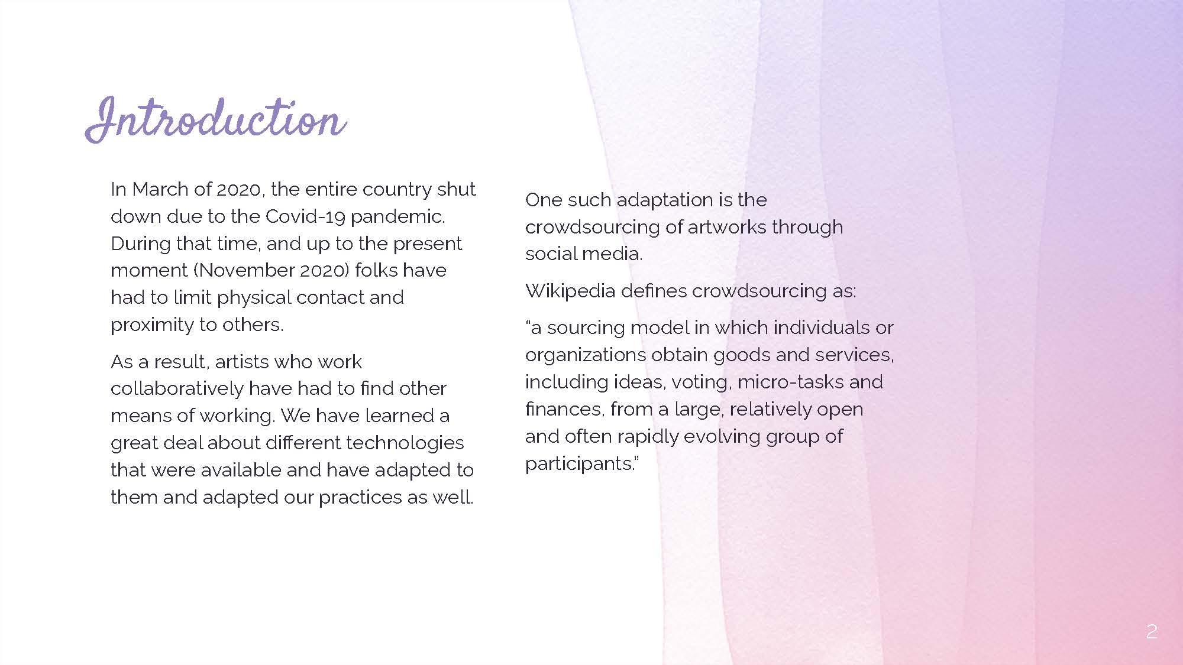
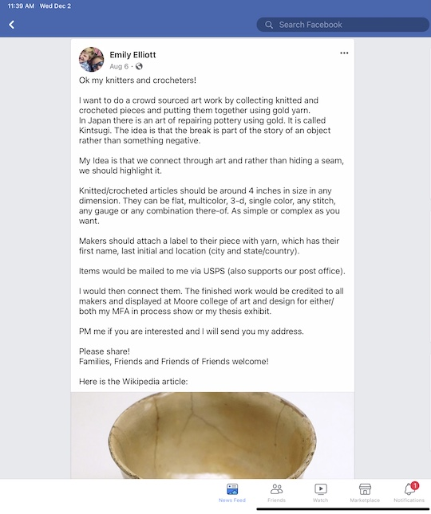
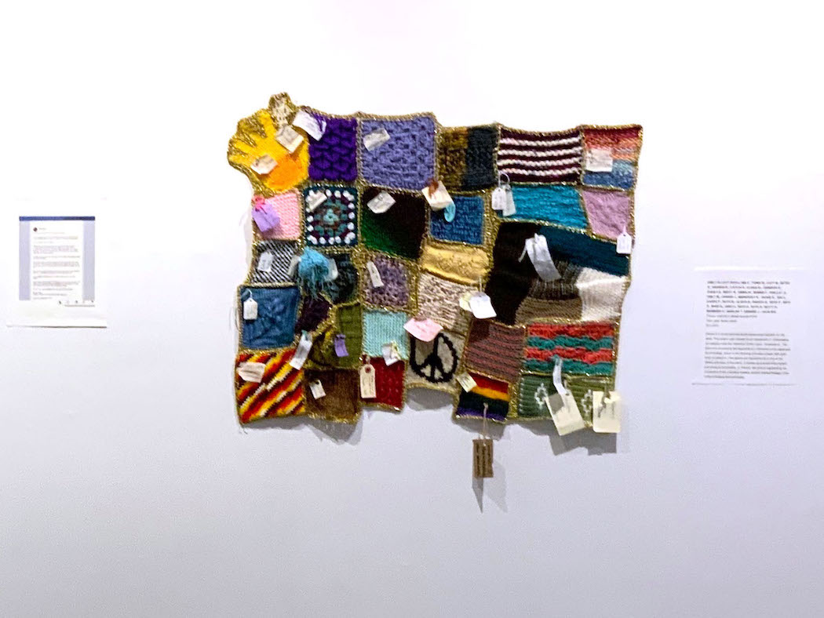
Pieces is a crowd sourced textile piece joined together by the artist. This project was initiated as an experiment in collaborative art making under the restriction of the Covid- 19 pandemic. The gold yarn connecting the segments is a reference to the Japanese art of kintsugi, which is the rejoining of broken pottery with gold, silver or platinum. The seams are highlighted as a part of the history and story of the piece. In textiles seams are often hidden and made to be invisible. In “Pieces” the artist is highlighting the connection of the individual crafters and the indirect lineage of the crafts of knitting and crocheting.

Emily Elliott and Lynn E., Fiona W., Katy M, Betsy B., Sharon B., Caitlin S., Elissa M., Jennifer R., Sheila S., Mindy M., Emma W., Debbie P., Shelley G., Emily M., Chrissi J., Margaret N., Jackie S., Jen H., Karen P., Ruth M., Alisha B., Breezy B., Beth P., Beth R., Saee B., Jane D., Beth S., Ruth S., Betty D., Barbara H., Marlise T., Desiree J., Julia S-H.

Collaborative Art Project
When we were all sent home in March of 2020, no one expected to be home for the next 6 months or longer. During that time, I felt a lack of connected-ness to my fellow students and other artists. There is a certain buzz that happens when artists are able to work together and among one another. The quarantine made me, and others, search for different ways to feel connected.
During the spring semester, my colleagues and professors and I were connected through virtual meetings and emails. My cohort set-up times to eat lunch “together” in zoom chats once a week. We were able to check in with one another, share work and experiences and feelings about the goings on in the world.
In May, at the end of the semester, what had been a practically constant parade of zoom meetings and virtual conferences stopped. That connection, left to our once monthly department “check-ins”.
In the beginning of June I had expected to start my summer job as an art teacher at Burn Brae Day Camp suburban Philadelphia, but by June 11, the camp had made a (very difficult, but smart) decision not to open for the 2020 season. Our camp was not alone, many others had decided not to open as well.
That left me, and many others, without the connection of other artists.
My graduate program at Moore College of Art and Design requires us to do a summer project. BC (before Corona) I had initially thought that I would work in-person with a small group of students on a student-led collaborative art project. AC, I had to move that project on-line. I decided the group would meet twice a week for about an hour. during that time, we would discuss our ideas and look at any work created between meetings.
I sent out a call for students, middle school age, on Facebook and received 4 responses.
What follows, is the result of 4 students, who did not know each other initially, creating collaborative art on a virtual platform.

Process Descriptions
The first “assignment” was an idea that I had to help us to learn to use the tools we have available and to get our art minds working. Each student was asked to make a “doodle” on a piece of notebook paper and then write a thought along with the doodle. The next week each student doodled on another person's doodle and wrote a thought, until all students had “touched” each doodle. Each doodle was uploaded to a google drive folder and students had the choice to either print out the drawing or draw with a computer or phone program. We experienced a few technical issues, but the result was 4 collaborative art works.

Doodle Art
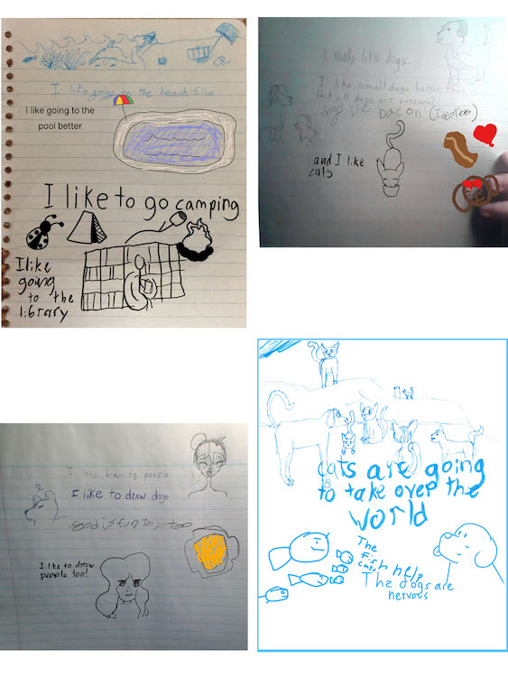

The next assignment was a themed artwork. I led and recorded the conversation while the participants brainstormed for ideas that they would like to make art about. After they had a significant list of ideas they voted and decided on “girls can do anything”. Each artist responded to the theme in their preferred method.
Theme Work
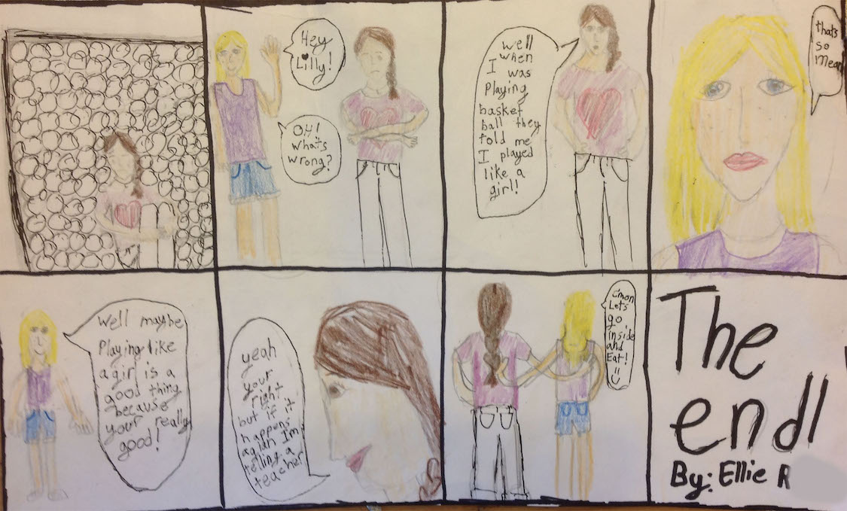
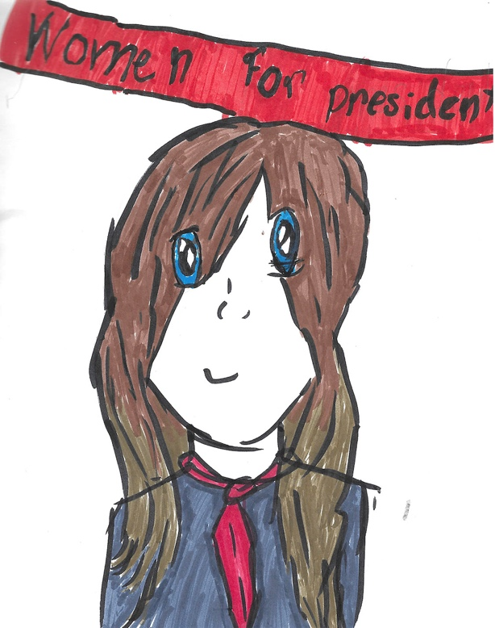
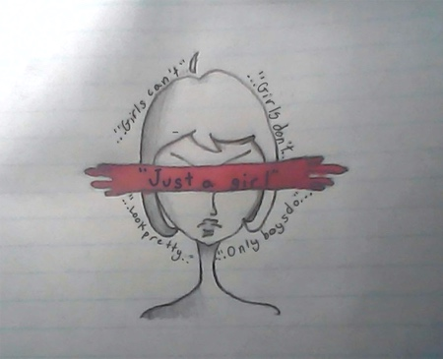
Julia S. Julia's animation
Virtual Whiteboard Art
We also discovered the “whiteboard” feature of Zoom. We spent 2 sessions creating art together in real time. These sessions were fun and times of discovery and shared leadership. I participated in the discovery process but stepped back for the “formal” art making.
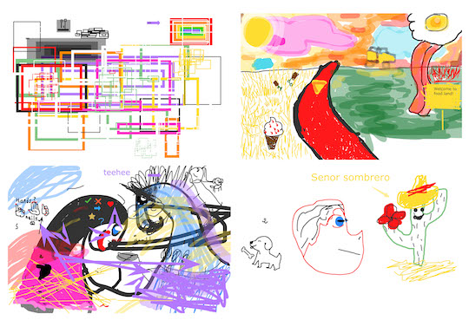

The final project was entirely student led. The conversation began with a few simple questions:
What would you like to do?
How will you make it collaborative?
The students brainstormed, I took notes and clarified. They chose to personify or make a character of inanimate objects. They brainstormed ways to add character to an object and process options. It was decided that each student would take 2-3 pictures of different objects and each would choose someone else’s picture to personify.
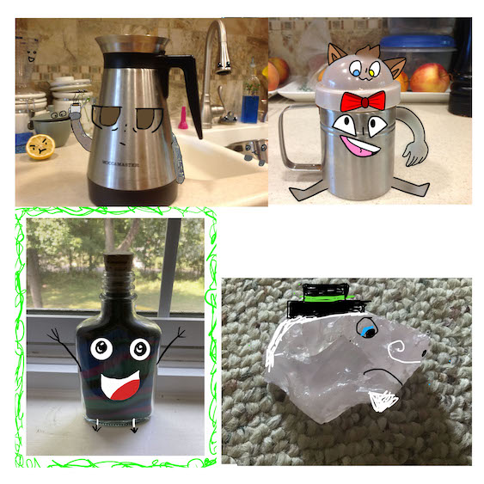

Building Spaces
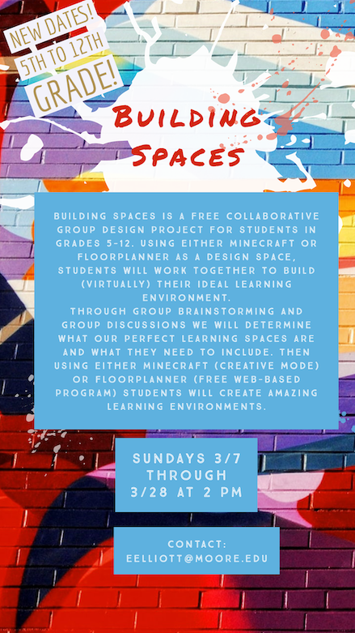
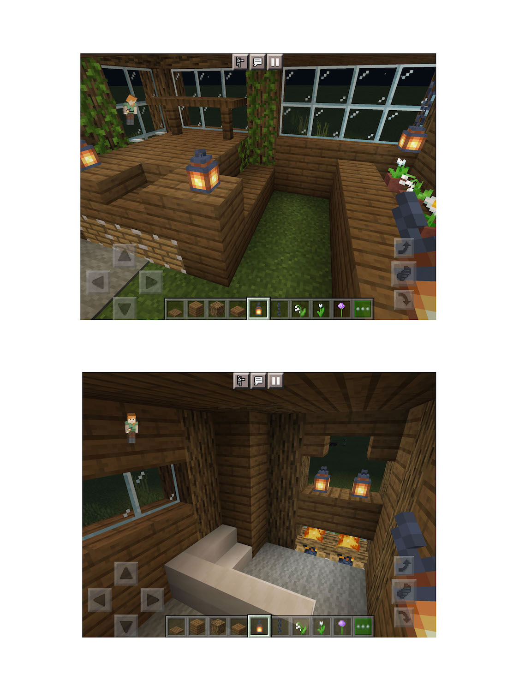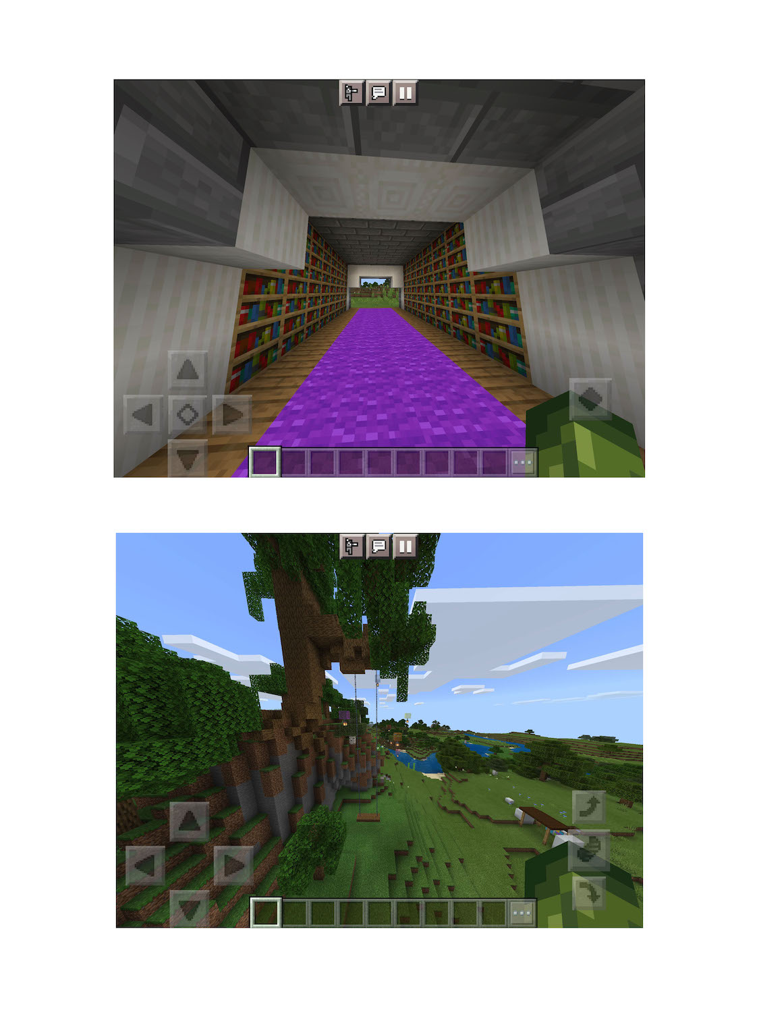
Elielle B. age 12
Fiona W. age 10
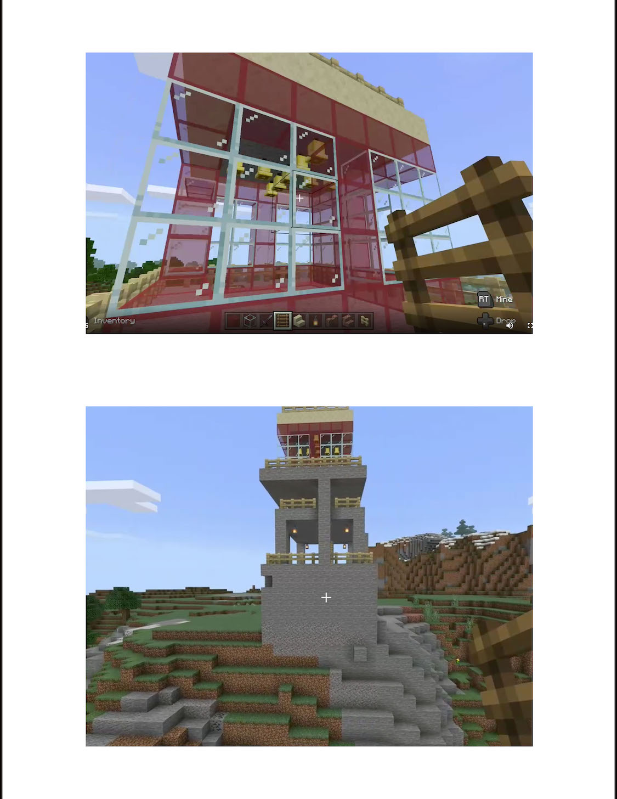
Jack Age 12

D. Recomposed 2021
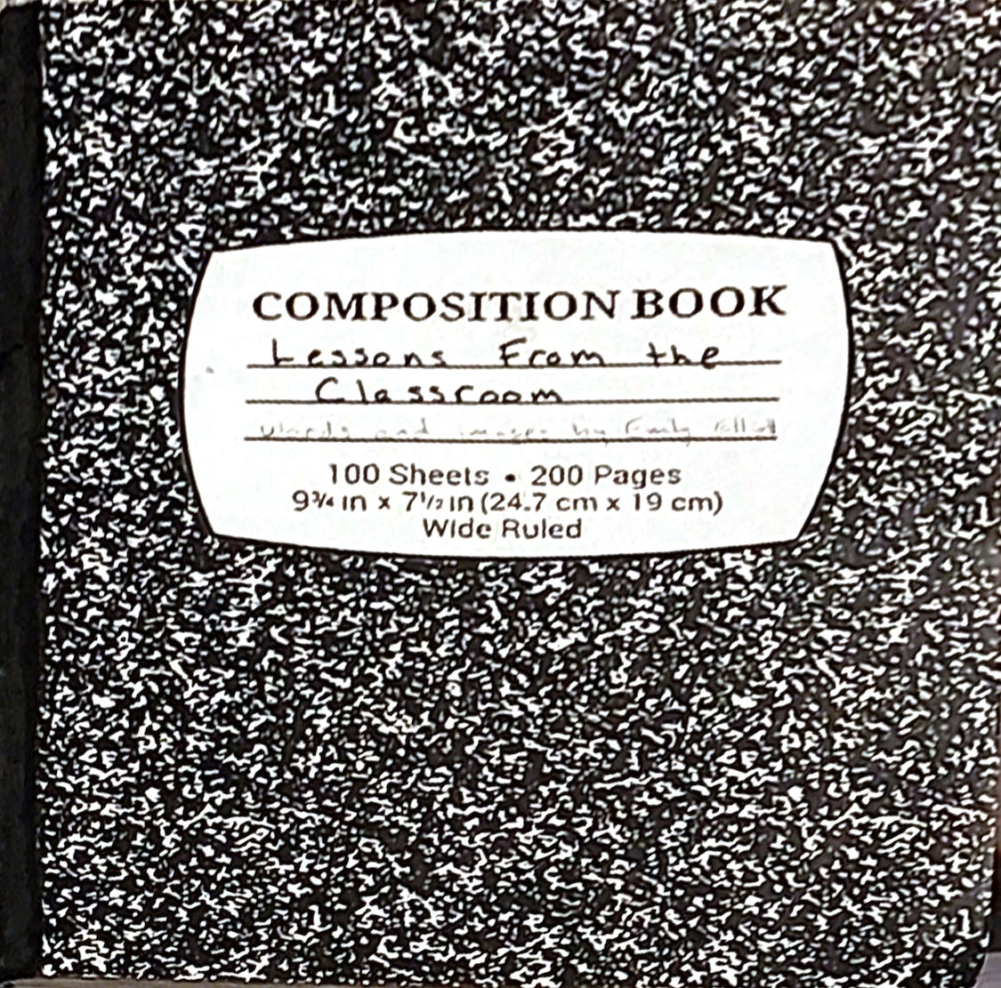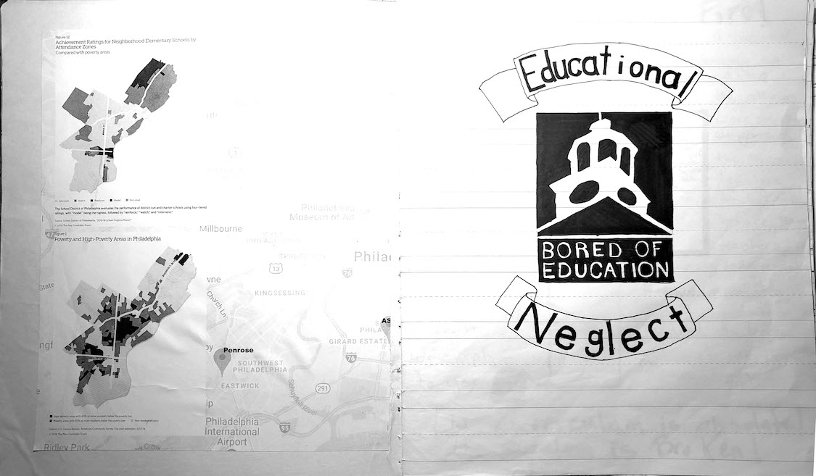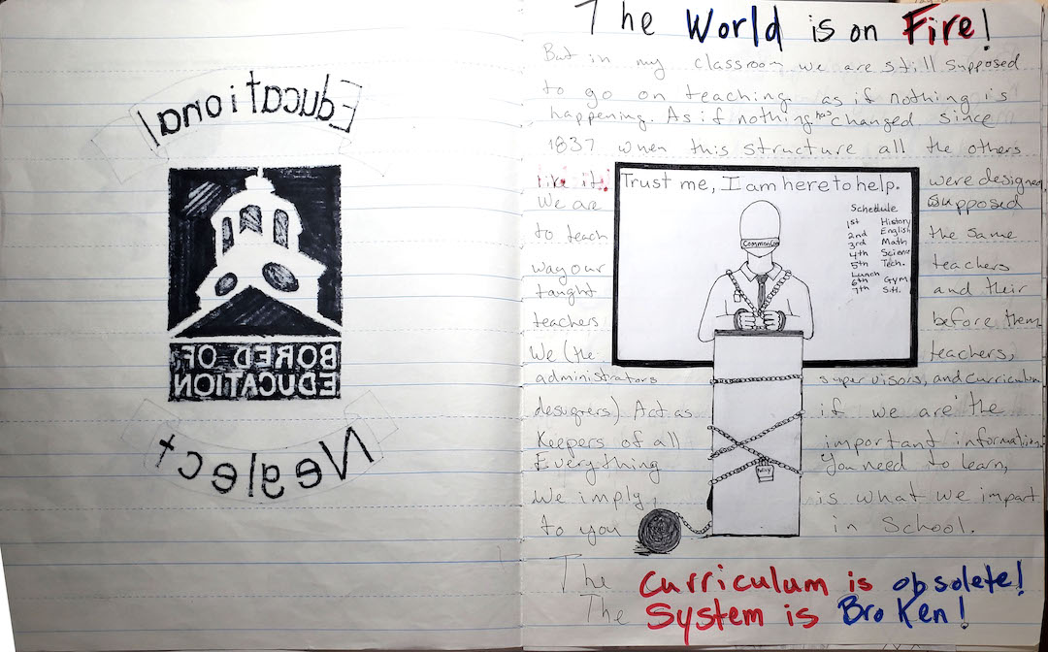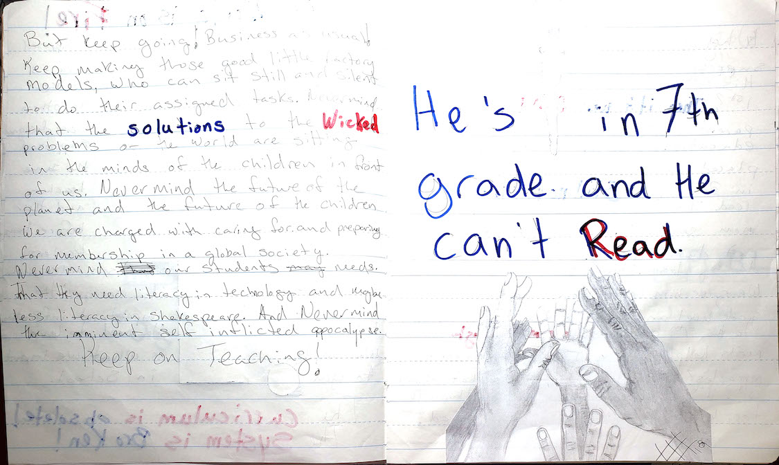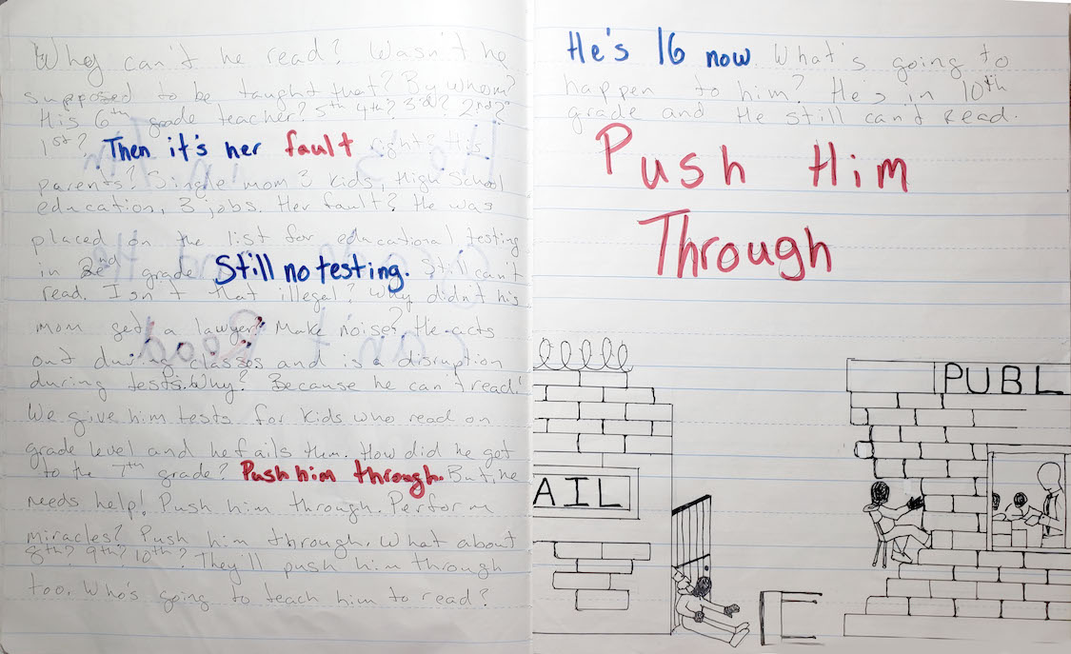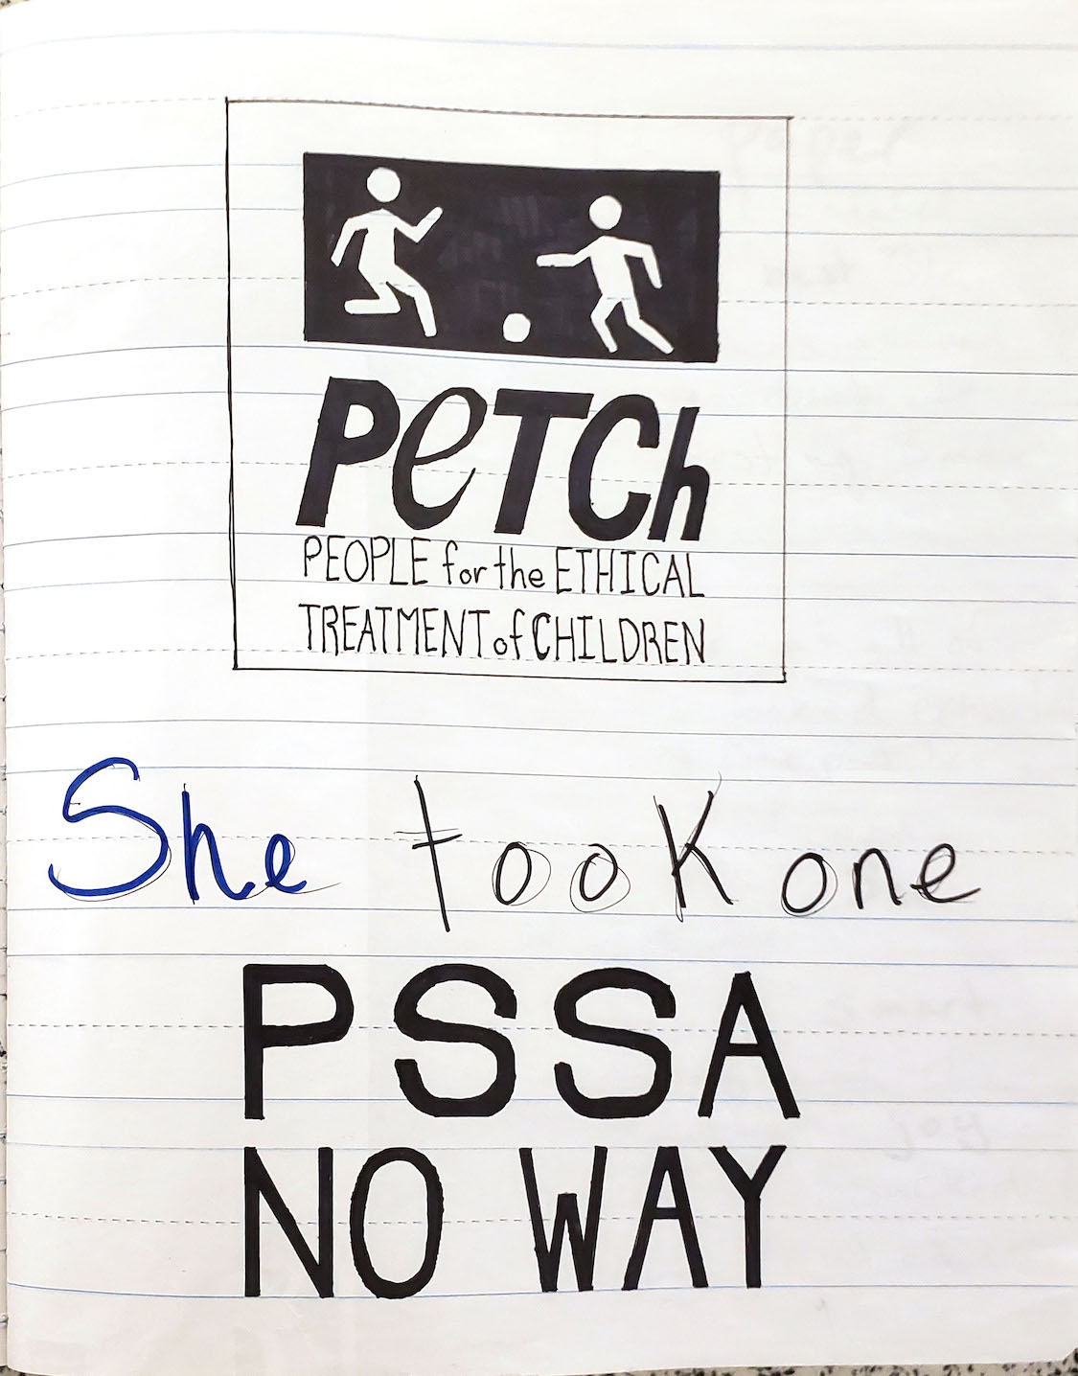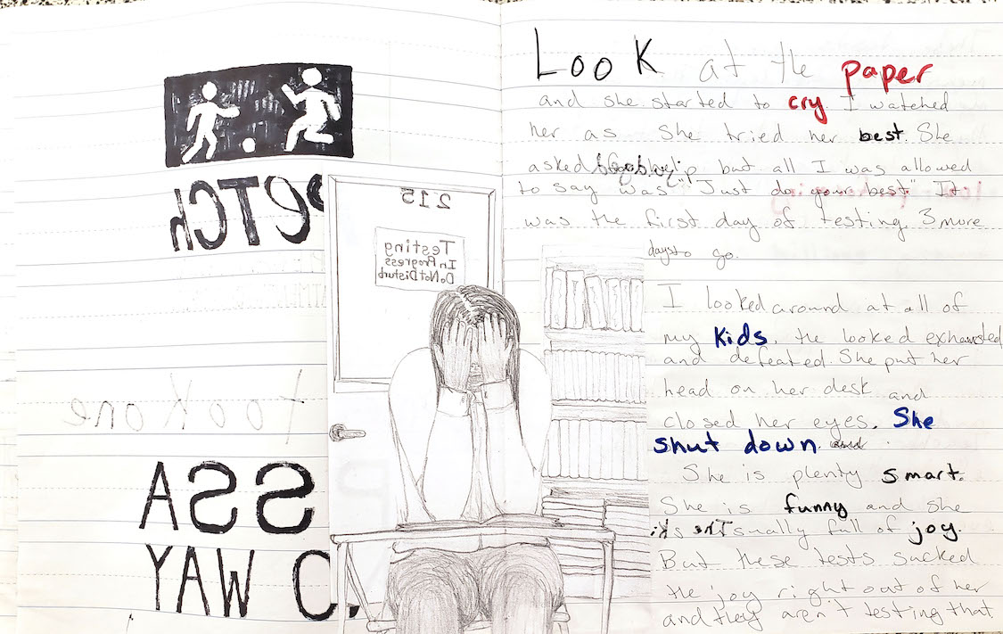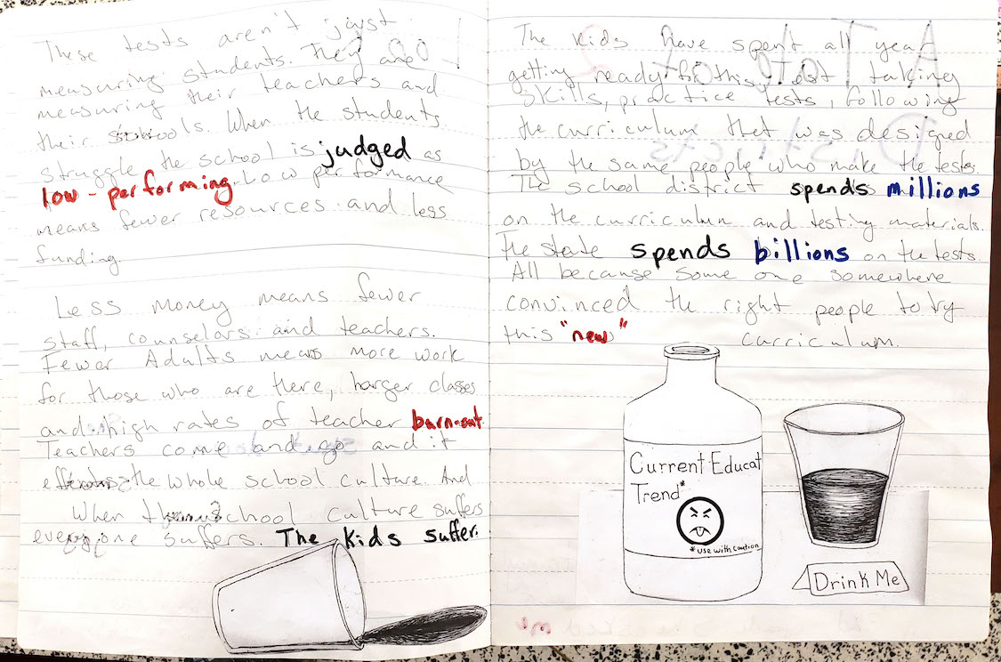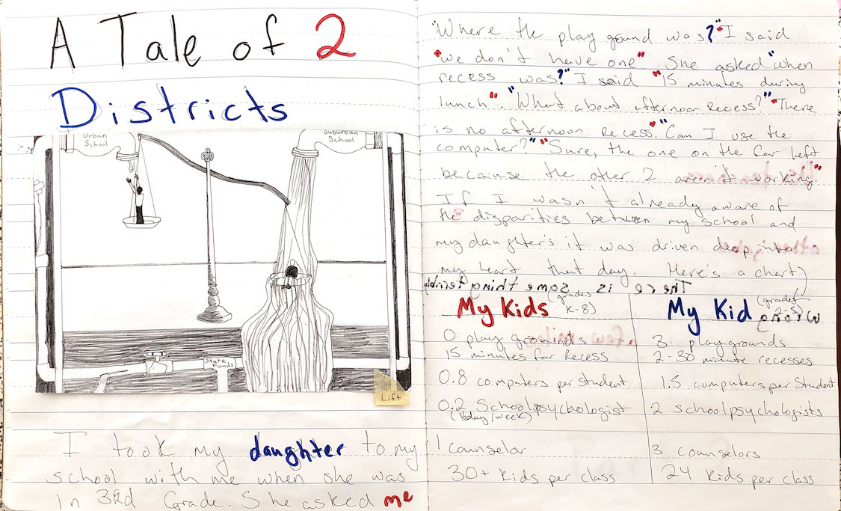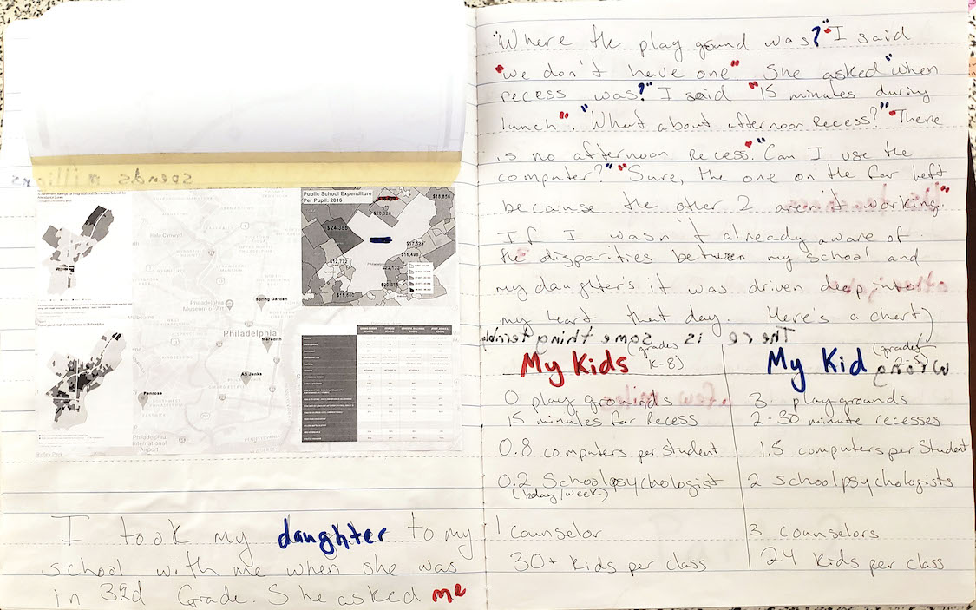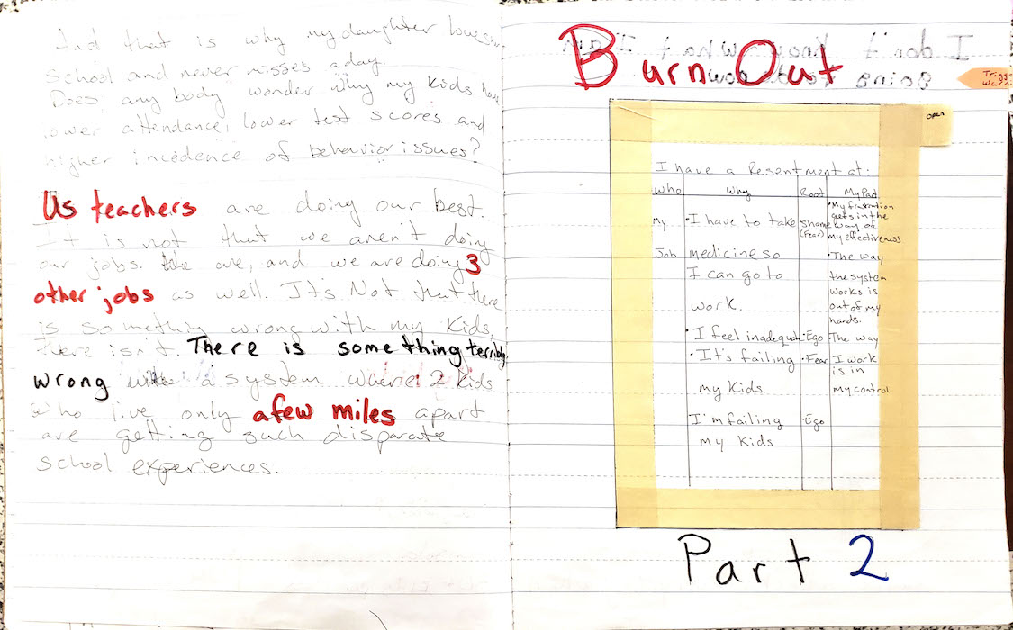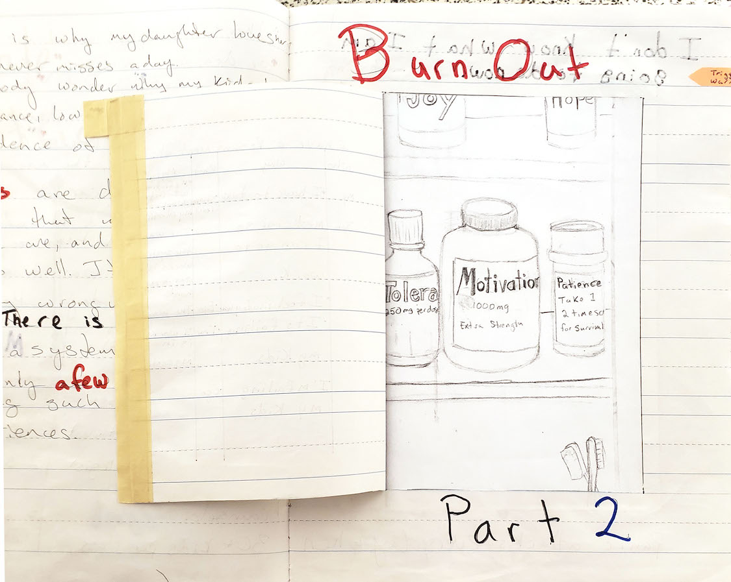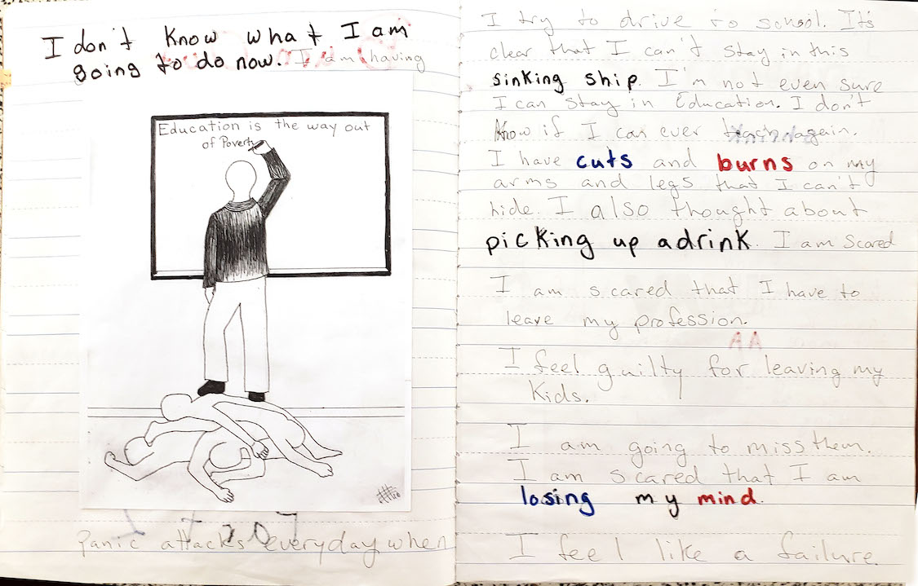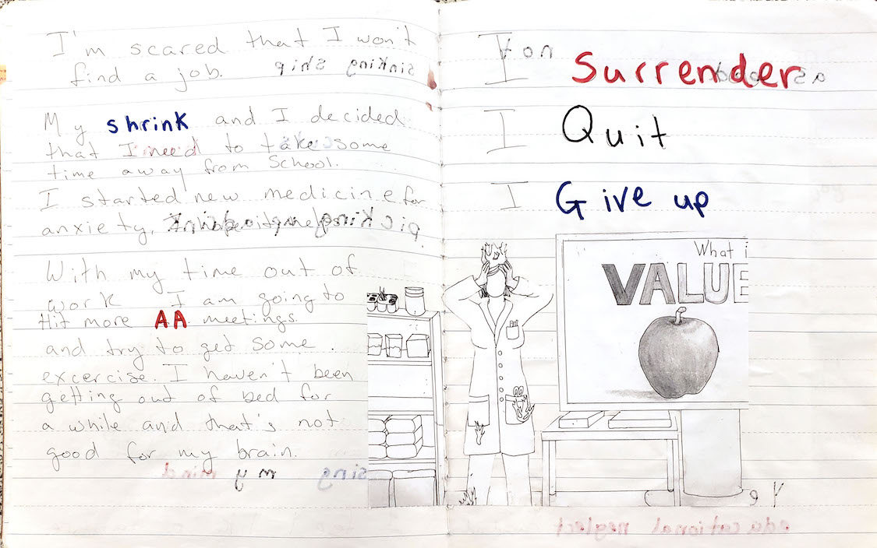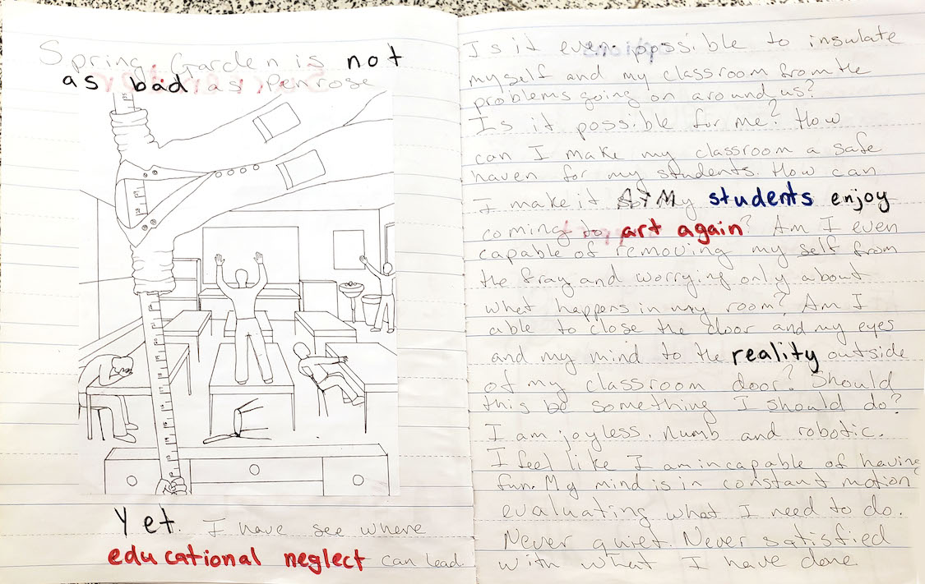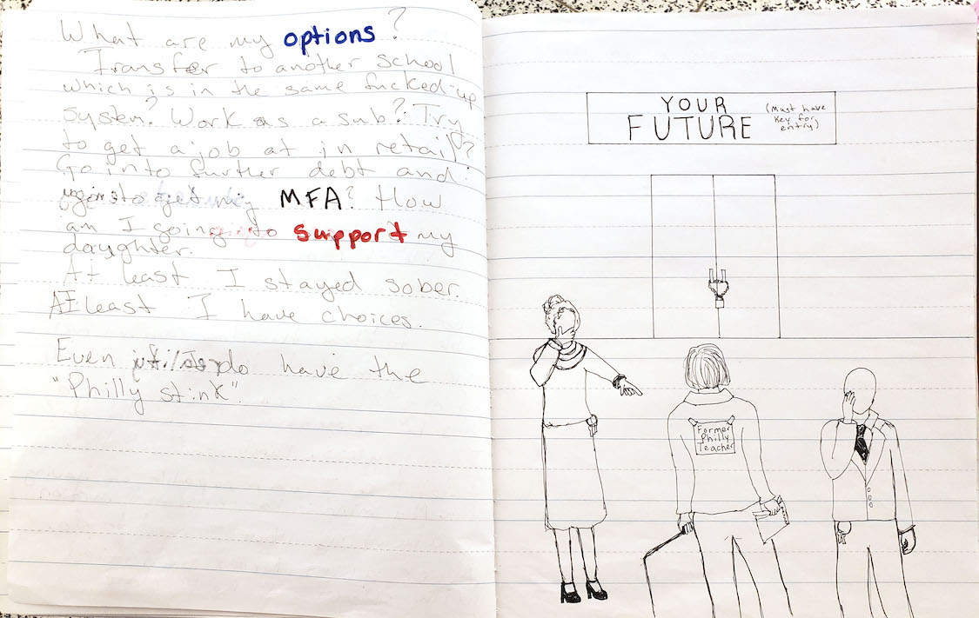

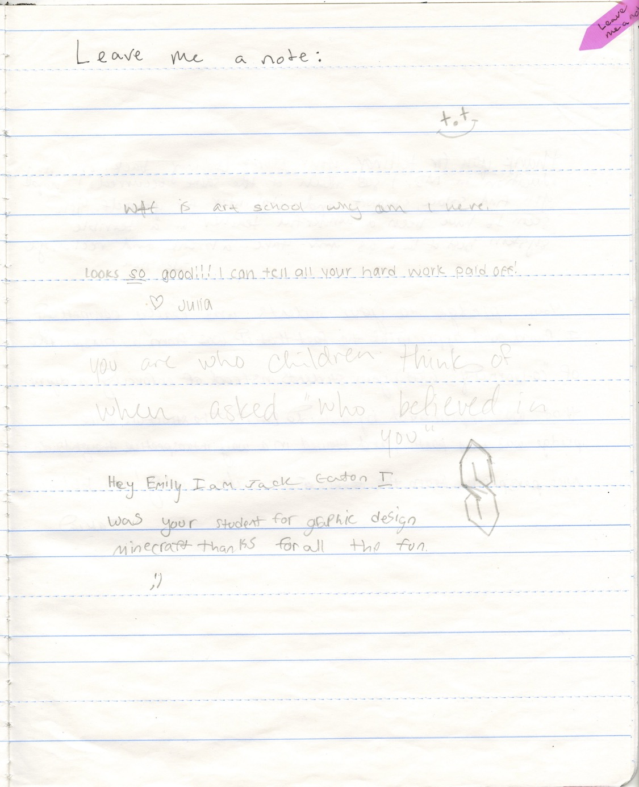

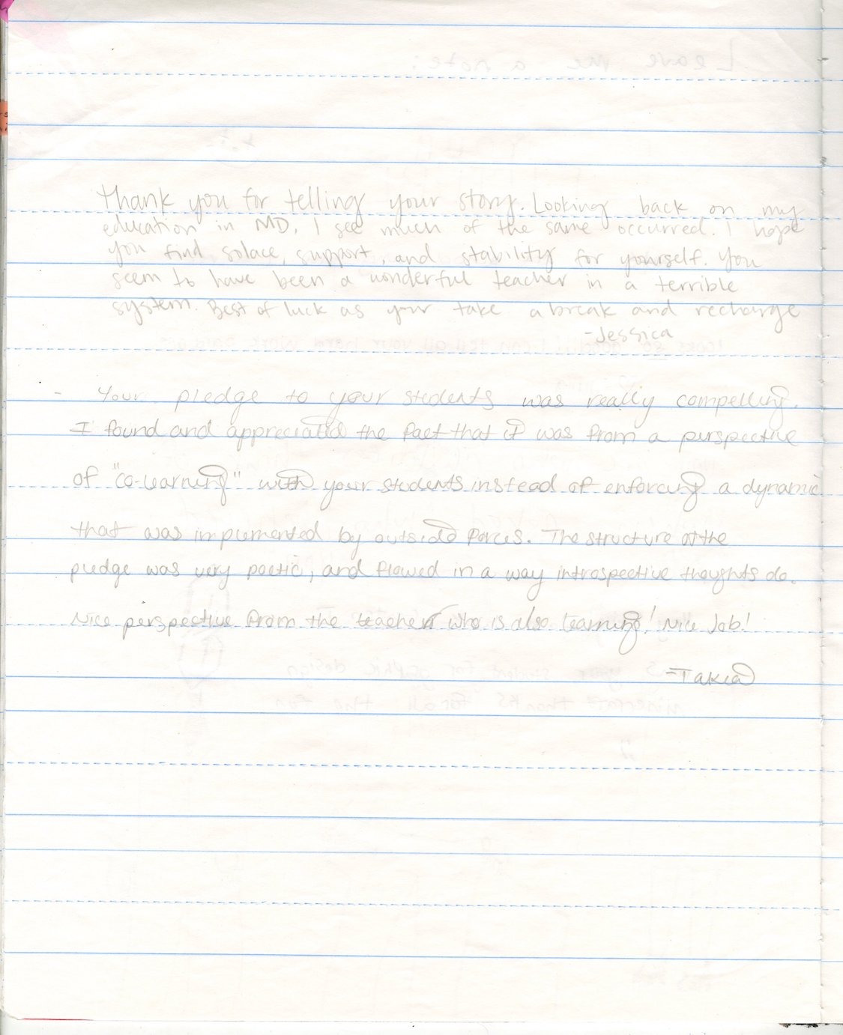

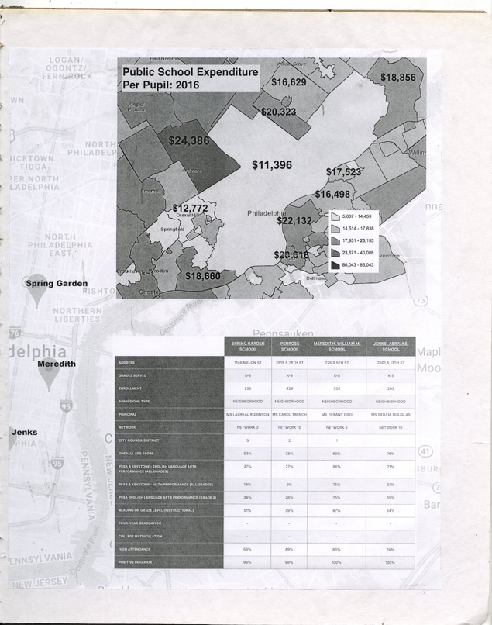

Ward, Henry. “Teaching As An Artistic Practice.” Dissertation, Middlesex University, 2013 pg. 38
See Appendices I and II
Tate. “Socially Engaged Practice – Art Term.” Accessed February 21, 2021. https://www.tate.org.uk/art/art-terms/s/socially-engaged-practice.
“What Is Artistic Practice.” IGI Global. Accessed February 21, 2021. https://www.igi-global.com/dictionary/artistic-practice/47005.
Tate. “Relational Aesthetics – Art Term.” Tate. Accessed February 21, 2021. https://www.tate.org.uk/art/art-terms/r/relational-aesthetics.
Grant Kester, Conversation Pieces, California: University of California Press, 2004, p. 10 “Art in which “the emphasis is on the character of [discursive] interaction, not the physical or formal integrity of a given artifact or the artist’s experience in producing it… Dialogical projects…unfold through a process of performative interaction.”
Helguera, Pablo Transpedagogy, pg. 3 “The migration of the discipline and methods of education into artmaking, resulting in a distinct medium where the artwork is constituted simultaneously of a learning experience or process and a conceptual gesture open to interpretation.”
Glavin, Chris. “Critical Pedagogy.” Critical Pedagogy | K12 Academics, February 6, 2014. https://www.k12academics.com/educational-philosophy/critical-pedagogy.
Freire, Paulo Pedagogy of the Oppressed, 30th anniversary edition, Continuum International Publishing, NY 1970/2000 foreword pg. 32
Racism, funding inequities, high-stakes testing, cultural erasure, etc.
See Davidson, Cathy N. The New Education: How to Revolutionize the University to Prepare Students for a World in Flux, 2017. Print; Emdin, Christopher For White Who Teach in the Hood and the rest of Y’all too. Beacon Press Boston, 2016; Culturally Responsive Differentiated Instruction: Narrowing Gaps Between Best Pedagogical Practices Benefiting All Learners by LORRI J. SANTAMARIA California State University, San Marcos Teachers Freire, Paulo Pedagogy of the Oppressed, 30th anniversary edition, Continuum International Publishing, NY 1970/2000 Freire, Paulo Pedagogy of the Oppressed, 30th anniversary edition, Continuum International Publishing, NY 1970/2000 College Record Volume 111, Number 1, January 2009, pp. 214–247; Bain, Ken. What the Best College Teachers Do. Cambridge MA: Harvard University Press, 2004. Etc.
Davidson, Cathy N. The New Education: How to Revolutionize the University to Prepare Students for a World in Flux. , 2017. Print; 35-40 Taylorism
Progressive education is “ideas and practices that aim to make schools more effective agencies of a democratic society” Rabin, Sarah, Georgina Achilles, Sarah Page, and Christopher Koliba. A Brief Overview of Progressive Education, September 6, 2002. http://www.uvm.edu/~dewey/articles/proged.html.
Founded in 1984, the Coalition of Essential Schools shut down their organization, but the principles remain in place in hundreds of schools across the country. They are: Learning to use one's mind well, Less is more: depth over coverage, Goals apply to all students, Personalization, Student as worker, teacher as coach, Demonstration of mastery, A tone of decency and trust, Commitment to the entire school, Resources dedicated to teaching and learning, Democracy and equity. https://www.edutopia.org/article/farewell-coalition-essential-schools-peter-poutiatine
In the fall of 2018, my school was scheduled for a walkthrough by the regional superintendent. All of the teachers were given a list of items that they must have in specific locations in our classrooms. The list included anchor charts, word walls, objectives for the lesson and the Common Core standard they address, lesson plans with the time of day the students should be working on each section of the lesson. The list went on. Each teacher was rated by these elements and either passed or failed the walk through and that was reflected in our evaluations and the school score.
Love, Bettina L. . We Want to Do More Than Survive. Beacon Press. Kindle Edition. pg. 27﻿-“educational survival complex, in which students are left learning to merely survive, learning how schools mimic the world they live in, thus making schools a training site for a life of exhaustion.”
Freire, Paulo Pedagogy of the Oppressed, 30th anniversary edition, Continuum International Publishing, NY 1970/2000
Ibid. pg.73
Appendix IV- D is a work of drawings and writing about my experiences in SDP
Love, Bettina pg. 89 “Still, some will leave the profession mentally, physically, and spiritually depleted, looking for a way to make an impact on education outside the classroom, but all are working to restore humanity with their eyes on abolishing the educational system as we know it.”
The schools in Philadelphia where I taught were all what they call “high needs” schools. High poverty, high incidence of special populations, low performing, predominantly Black and Brown children.
Davidson, Cathy N. The New Education: How to Revolutionize the University to Prepare Students for a World in Flux. , 2017. Print.
Bain, Ken
Art school: (propositions for the 21st century) / edited by Steven Henry Madoff. 2009, Allen, F. (2011); Education. London: Whitechapel Gallery. Allen, F. (2011). Education. London: Whitechapel Gallery
See Appendix IV- A
See Appendix IV- B and C
Zeleznik, George. “Encouraging Critically Engaged Citizens: So What?” NAIS, 2011. https://www.nais.org/magazine/independent-school/spring-2011/encouraging-critically-engaged-citizens-so-what/.
Friere Paulo pg. 81
Dewey, John. 1916. Democracy and education: an introduction to the philosophy of education. New York: Macmillan. “In other words, what he learns are connections. {...} We learn what things are hard and what are soft by finding out through active experimentation what they respectively will do and what can be done and what cannot be done with them.”
Freire, Paulo Pedagogy of the Oppressed, 30th anniversary edition, Continuum International Publishing, NY 1970/2000 “the problem-posing educator constantly re-forms his reflections in the reflection of the students. The students—no longer docile listeners—are now critical co-investigators in dialogue with the teacher. The teacher presents the material to the students for their consideration and re-considers her earlier considerations as the students express their own. The role of the problem-posing educator is to create; together with the students, the conditions under which knowledge at the level of the doxa is superseded by true knowledge, at the level of the logos,”
hooks, bell Teaching to Transgress. NY: Rutledge, 1994
Interview with Grant Kester Transcript of the entire interview by Martin Krenn with Grant Kester, 10th December 2013, Belfast/San Diego
Dewey, John. Art as Experience. New York: Putnam, 1980. pg. 4
Projects, Platforms, and Practices​, framework by Caroline Woolard, April 2018 Draft, Pg. 1
Dewey, John. Art as Experience (p. 9).
Bourriaud, Nicolas. Relational Aesthetics. [Dijon]: Les Presses du Réel, 2002 pg. 113
Bain, Ken, author. What the Best College Students Do. Cambridge, Massachusetts: The Belknap Press of Harvard University Press, 2012.
Kocur, Zoya, and Simon Leung. Theory in Contemporary Art since 1985. Chichester, West Sussex: Wiley-Blackwell, 2013. Conversation Pieces: The Role of Dialogue in Socially Engaged Art, Grant Kester
Thompson, Nato (2012). Living as Form, Socially Engaged Art from 1991-2011. Cambridge: MIT Press
Ward, Henry. “Teaching As An Artistic Practice” Dissertation, Middlesex University, 2013. Pg. 38
Bishop, C. (2012). Artificial hells: Participatory art and the politics of spectatorship. London: Verso Books. p. 243.
Ibid.
Ibid.
Bruguera, Tania. “Tania Bruguera: Artist Statement.” tania Bruguera | Artist Statement, 2009. http://www.taniabruguera.com/cms/395-0-Artist+Statement.html.
Bishop, C. (2012). Artificial hells: Participatory art and the politics of spectatorship. London: Verso Books. p. 248.
Art School: (propositions for the 21st century), edited by Steven Henry Madoff. 2009 On the Ground, Practical Observations for Regenerating Art Education (Ernesto Pujol)
Pujol, Ernesto. “The Listeners.” The Brooklyn Rail, December 8, 2018. https://brooklynrail.org/2018/12/1by1/The-Listeners-Ernesto-Pujol-2018.
Ibid.
Helguera, Pablo. “Transpedagogy.” s3.amazonaws.com, n.d. https://s3.amazonaws.com/arena-attachments/75021/helguera_transpedagogy.pdf.
Helguera, Pablo. Education for Socially Engaged Art. Jorge Pinto Books Inc., 2012. Kindle edition.
Helguera, Pablo. “Transpedagogy.” s3.amazonaws.com, n.d. https://s3.amazonaws.com/arena-attachments/75021/helguera_transpedagogy.pdf.
Tim Rollins was an artist best known for his work with K.O.S (Kids of Survival), a group of At-risk students, in New York City from 1984 through the early 2010s.e
Illustration 1
Illustration 2
Full case study appears in Appendix III
Illustrations 3-5
Full case study appears in Appendix III
Grady, Elizabeth
Osorio, Pepòn. Interviewed by Emily Elliott. Phone interview, November 12, 2020
In Grady’s article the number is 75, in my interview with Osorio the number he gave was 150-200
Osorio, Pepòn. Interviewed by Emily Elliott. Phone interview, November 12, 2020
ReForm Project http://reform-project.org.
Osorio, Pepòn. Interviewed by Emily Elliott. Phone interview, November 12, 2020
Grady, Elizabeth. “Pepón Osorio: The Impact of ReForm.” FIELD, 2018. http://field-journal.com/issue-9/pepon-osorio-the-impact-of-reform.
Ibid. Chelsey said, “At first I didn’t know it was an art project. I thought it was something simple, just talking about Fairhill and how we felt.” Lynoshka echoed, “We didn’t even know he was a famous artist. We thought he was just some guy who wanted to do an exhibit at a college.”
Osorio uses “incite” to mean “move to action” Osorio, Pepòn. Interviewed by Emily Elliott. Phone interview, November 12, 2020
See Bob Ross’s “Happy Accident”
Risë Wilson, “Hide and Seek: In Search of Reform,” in Pepón Osorio, ReForm (Philadelphia: Temple University, 2016), pp. 27-37.
Grady, Elizabeth
Gordon, David, Anne Meyer, and David Rose. Universal Design for Learning. Wakefield, MA: CAST Professional Publishing, 2016.
Freire, Paulo Pedagogy of the Oppressed, 30th anniversary edition, Continuum International Publishing, NY 1970/2000
Ibid. pg. 95
Emdin, Christopher For White People Who Teach in the Hood… and the Rest of Y’all Too, Beacon Press Boston, 2016
Ibid.
Ibid.
Freire, Paulo pg. 89
Love, Bettina L. . We Want to Do More Than Survive. Beacon Press. Kindle Edition. pg. 100
Ibid. pg. 100
Freire, Paulo pg. 81
References to multidisciplinary/interdisciplinary education appear in Cathy N. The New Education: How to Revolutionize the University to Prepare Students for a World in Flux., 2017. Print: Emdin, Christopher For White Who Teach in the Hood and the rest of Y’all too. Beacon Press Boston, 2016; Culturally Responsive Differentiated Instruction: Narrowing Gaps Between Best Pedagogical Practices Benefiting All Learners by LORRI J. SANTAMARIA California State University, San Marcos Teachers College Record Volume 111, Number 1, January 2009, pp. 214–247; Bain, Ken. What the Best College Teachers Do. Cambridge MA: Harvard University Press, 2004. Etc.
Freire, Paulo pg. 77
Beetham, Helen and Sharpe, Rhona. “An Introduction to Rethinking Pedagogy,” in Rethinking Pedagogy for a Digital Age. New York: Routledge, 2007. Pg. 8 “When we talk about design for learning we are viewing design as an intentional and systematic, but also a creative approach to the encounter of learners with subject matter and task requirements. In reality learners and learning situations are unpredictable: as teachers, we encourage learners to engage in dialogue with us, to respond individually to learning opportunities, and to take increasing responsibility for their own learning.”
Freire, Paulo Pedagogy of the Oppressed pg. 73 “The capability of banking education to minimize or annul the students’ creative power and to stimulate their credulity serves the interests of the oppressors, who care neither to have the world revealed nor to see it transformed.”
Asset-based approaches focus on activating the creative potential in communities and elevating creative outputs to further other placemaking goals. Vazquez, Leonardo, Creative Placemaking: Integrating Community, Cultural and Economic Development (November 1, 2012) https://ssrn.com/abstract=2474862 or http://dx.doi.org/10.2139/ssrn.2474862
Cultural competency is a set of knowledge and skills to help individuals engage more effectively in culturally diverse environments. Vazquez, Leonardo, Principles of culturally competent planning and placemaking AICP/PP
DeAngelis, Tori. “In Search of Cultural Competence.” Monitor on Psychology. American Psychological Association, March 2015. https://www.apa.org/monitor/2015/03/cultural-competence.
Hooks, Bell. Teaching to Transgress: Education as the Practice of Freedom. New York, NY: Routledge, 2017. Pg. 33
Volta, Benjamin (artist) in discussion with the author, September 2020
Dewey, John. My Pedagogic Creed. Nabu Press, 2010.
Love, Bettina L. We Want to Do More Than Survive (p. 13). Beacon Press. Kindle Edition.
Carr, Christopher Banks. “The Philosophers Room.” CURATING THE CLASSROOM, February 13, 2019. https://curatingtheclassroom.org/saason/.
Wong, Harry K. The First Days of chool. Mountain View, CA: Harry K. Wong Publications, 1998. Pg. 94
See https://www.pblworks.org/research/partners, http://www.communityschools.org, http://udloncampus.cast.org/home, https://www.crefeld.org/new-page
Love, Bettina L. We Want to Do More Than Survive. Beacon Press. Kindle Edition. p. 89
Ibid. pg. 27﻿ “educational survival complex, in which students are left learning to merely survive, learning how schools mimic the world they live in, thus making schools a training site for a life of exhaustion.
The School Reform Commission was the state-run governing body of 5 members appointed by PA state government that operated the school district of Philadelphia from 2001 until 2018
http://field-journal.com/issue-9/pepon-osorio-the-impact-of-reform
Dewey, John. 1916. Democracy and education: an introduction to the philosophy of education. New York: Macmillan. “In other words, what he learns are connections. {...} We learn what things are hard and what are soft by finding out through active experimentation what they respectively will do and what can be done and what cannot be done with them.”
Freire, Paulo Pedagogy of the Oppressed, 30th anniversary edition, Continuum International Publishing, NY 1970/2000 “the problem-posing educator constantly re-forms his reflections in the reflection of the students. The students—no longer docile listeners—are now critical co-investigators in dialogue with the teacher. The teacher presents the material to the students for their consideration and re-considers her earlier considerations as the students express their own. The role of the problem-posing educator is to create; together with the students, the conditions under which knowledge at the level of the doxa is superseded by true knowledge, at the level of the logos,”
Interview with Grant Kester Transcript of the entire interview by Martin Krenn with Grant Kester, 10th December 2013, Belfast/San Diego
Grady, Elizabeth http://field-journal.com/issue-9/pepon-osorio-the-impact-of-reform
Warren, Mark, “School Closing and Community Openings”, ReForm, Temple Contemporary 2016: 55-68 Cornerhouse, Manchester, UK
Grady, Elizabeth
Osorio, Pepòn. Interviewed by Emily Elliott. Phone interview, November 12, 2020
In Grady’s article the number is 75, in my interview with Osorio the number he gave was 150-200
Osorio, Pepòn. Interviewed by Emily Elliott. Phone interview, November 12, 2020
ReForm Project Facebook page. The website that had been a source for this paper suddenly disappeared one day while I was taking notes. The facebook page remains.
Chelsey Velez, “When We Speak You Listen,” in Pepón Osorio, ReForm (Philadelphia: Temple University, 2016). It’s time that when we speak you listen!/It’s time that when we speak you listen!/When we speak you listen!/Why us we are now a broken family; When we speak you listen!/Saying it’s all the students’ fault/with all gad grades by how/can we do better if there/is only a few public schools/ with enough material for a few/classes and teachers barely getting paid./When we speak you listen: When we speak you listen!/Everyday looking straight into my/Parents’ eyes saying mom I don’t/want to leave my friends behind/We are now a broken family/When we speak you listen!/When we speak you listen!/When we speak you listen!/Where is all the money going?/They’re spending 15 million dollars/at Love park money down the drain/let Love Park stay the same it’s already iconic./We are not history Spend the/money on the Kids feed my/brain I want to make history/When we speak you listen/Taking our schools is just not right/it leaves to two options. JAIL or DEAD/DEAD or JAIL/ JAIL or DEAD/DEAD or JAIL/ JAIL or DEAD/DEAD or JAIL/Or schools closed down so suddenly/We won’t forget. We will remember those days./but I didn’t get to graduate/My friends graduated, my brother/graduated. My sister graduated/but I didn’t get A CHANCE/It’s not fair we all said but I/guess it never be it’s just the way it is./It’s TIME THAT WHEN WE SPEAK YOU LISTEN! YOU LISTEN!!
Osorio, Pepòn. Interviewed by Emily Elliott. Phone interview, November 12, 2020
Grady, Elizabeth http://field-journal.com/issue-9/pepon-osorio-the-impact-of-reform
Ibid. Chelsey said, “At first I didn’t know it was an art project. I thought it was something simple, just talking about Fairhill and how we felt.” Lynoshka echoed, “We didn’t even know he was a famous artist. We thought he was just some guy who wanted to do an exhibit at a college.”
Osorio, Pepòn. Interviewed by Emily Elliott. Phone interview, November 12, 2020
See Bob Ross’s “Happy Accident”
Risë Wilson, “Hide and Seek: In Search of Reform,” in Pepón Osorio, ReForm (Philadelphia: Temple University, 2016), pp. 27-37.
Grady, Elizabeth
Osorio, Pepòn. Interviewed by Emily Elliott. Phone interview, November 12, 2020
I did not record this interview, but I took notes during the conversation

